Differential equations
Please remember to photocopy 4 pages onto one sheet by going A3→A4 and using back to back on the photocopier

This booklet contains every higher level (and most ordinary level) questions that have appeared on exam papers from 1971 – 2023
Note that this topic was usually Question 10 on the old syllabus (up to 2022)
Fully worked solutions from the legend that is Dominick Donnelly here appliedmathematics.ie/index.php/students/exam-solutions
Solutions to HL 2023 and Sample Paper (plus lots more) from Joe Kennedy here: https://www.jkmaths.net/exam-paper-solutions
Screencasts of worked solutions to HL 2023 and Sample Paper (plus lots more) from Shane Molloy here: https://www.molloymaths.com/applied-maths

Exam Papers (in pdf and Word format) plus Marking Schemes (and lots more) from: thephysicsteacher.ie/exammaterialappliedmaths.html
A good idea is to look at as many sources as you can for solutions as there is often more than one approach and some can be much easier to understand and/or remember than others.
Screencasts of worked solutions to various older past paper question plus comprehensive resources for all topics

Questions from 2023 and Sample Paper (Ordinary level and Higher level) are left until the very end – page 43

You can find this document plus all other Applied Maths booklets on the homepage of thephysicsteacher.ie

Last updated: 04/11/2023
Noel Cunningham

Contents
Logs 3
Revision of logs 3
Worked example 1 3
Worked example 2 4
Exercises 5
Solutions 6
Merry X-mas 7
Revision of integration 9
Commonly asked integrals 9
Exam questions: Part ‘a’s 12
Integration by substitution 15
Questions requiring integration by substitution 19
Second order differential equations 20
Should I use constants of integration or limits? 22
Motion expressed in terms of acceleration 23
acceleration is proportional to the square of the speed 24
General acceleration questions 25
Linking displacement and time 27
Work done by a variable force 34
Power, force and velocity 35
Difficult/very difficult questions 37
Applying differential equations to non-mechanics questions 38
Guide to answering the exam questions 40
Differential equation questions from 2023 and Sample Paper: Ordinary level and Higher level 43
Integration and differentiation 47

Introduction

Up until now anytime we needed to connect v, u, a, s or t, we simply used our equations of motion.
These equations only work however if the acceleration is constant.
In this chapter we will see that the acceleration is not constant and therefore we need to resort to integration to help us.
Before we get into the questions we first need to make sure that we are comfortable manipulating expressions involving natural logs - see below.

Logs

Revision of logs

If $lnln x$= y then x = $e^{y}$

$$lnln a+lnln b=lnln ab$$ | $$lnln a-lnln b=lnln \frac{a}{b}$$
$$a = {lnln a }^{n}$$

Worked example 1
The following scanned sections are taken from Fundamental Applied Maths by Oliver Murphy (old edition)
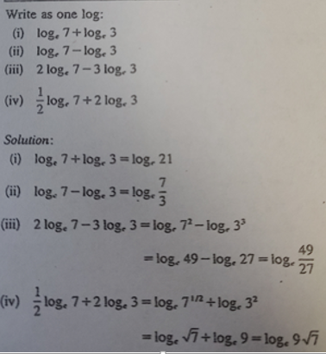

Worked example 2
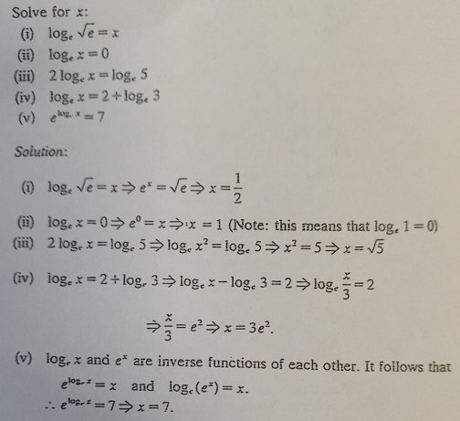

Exercises
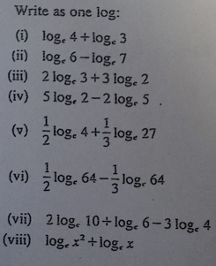 | 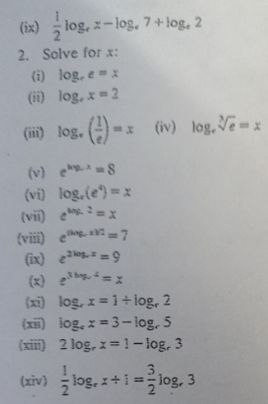

Solutions

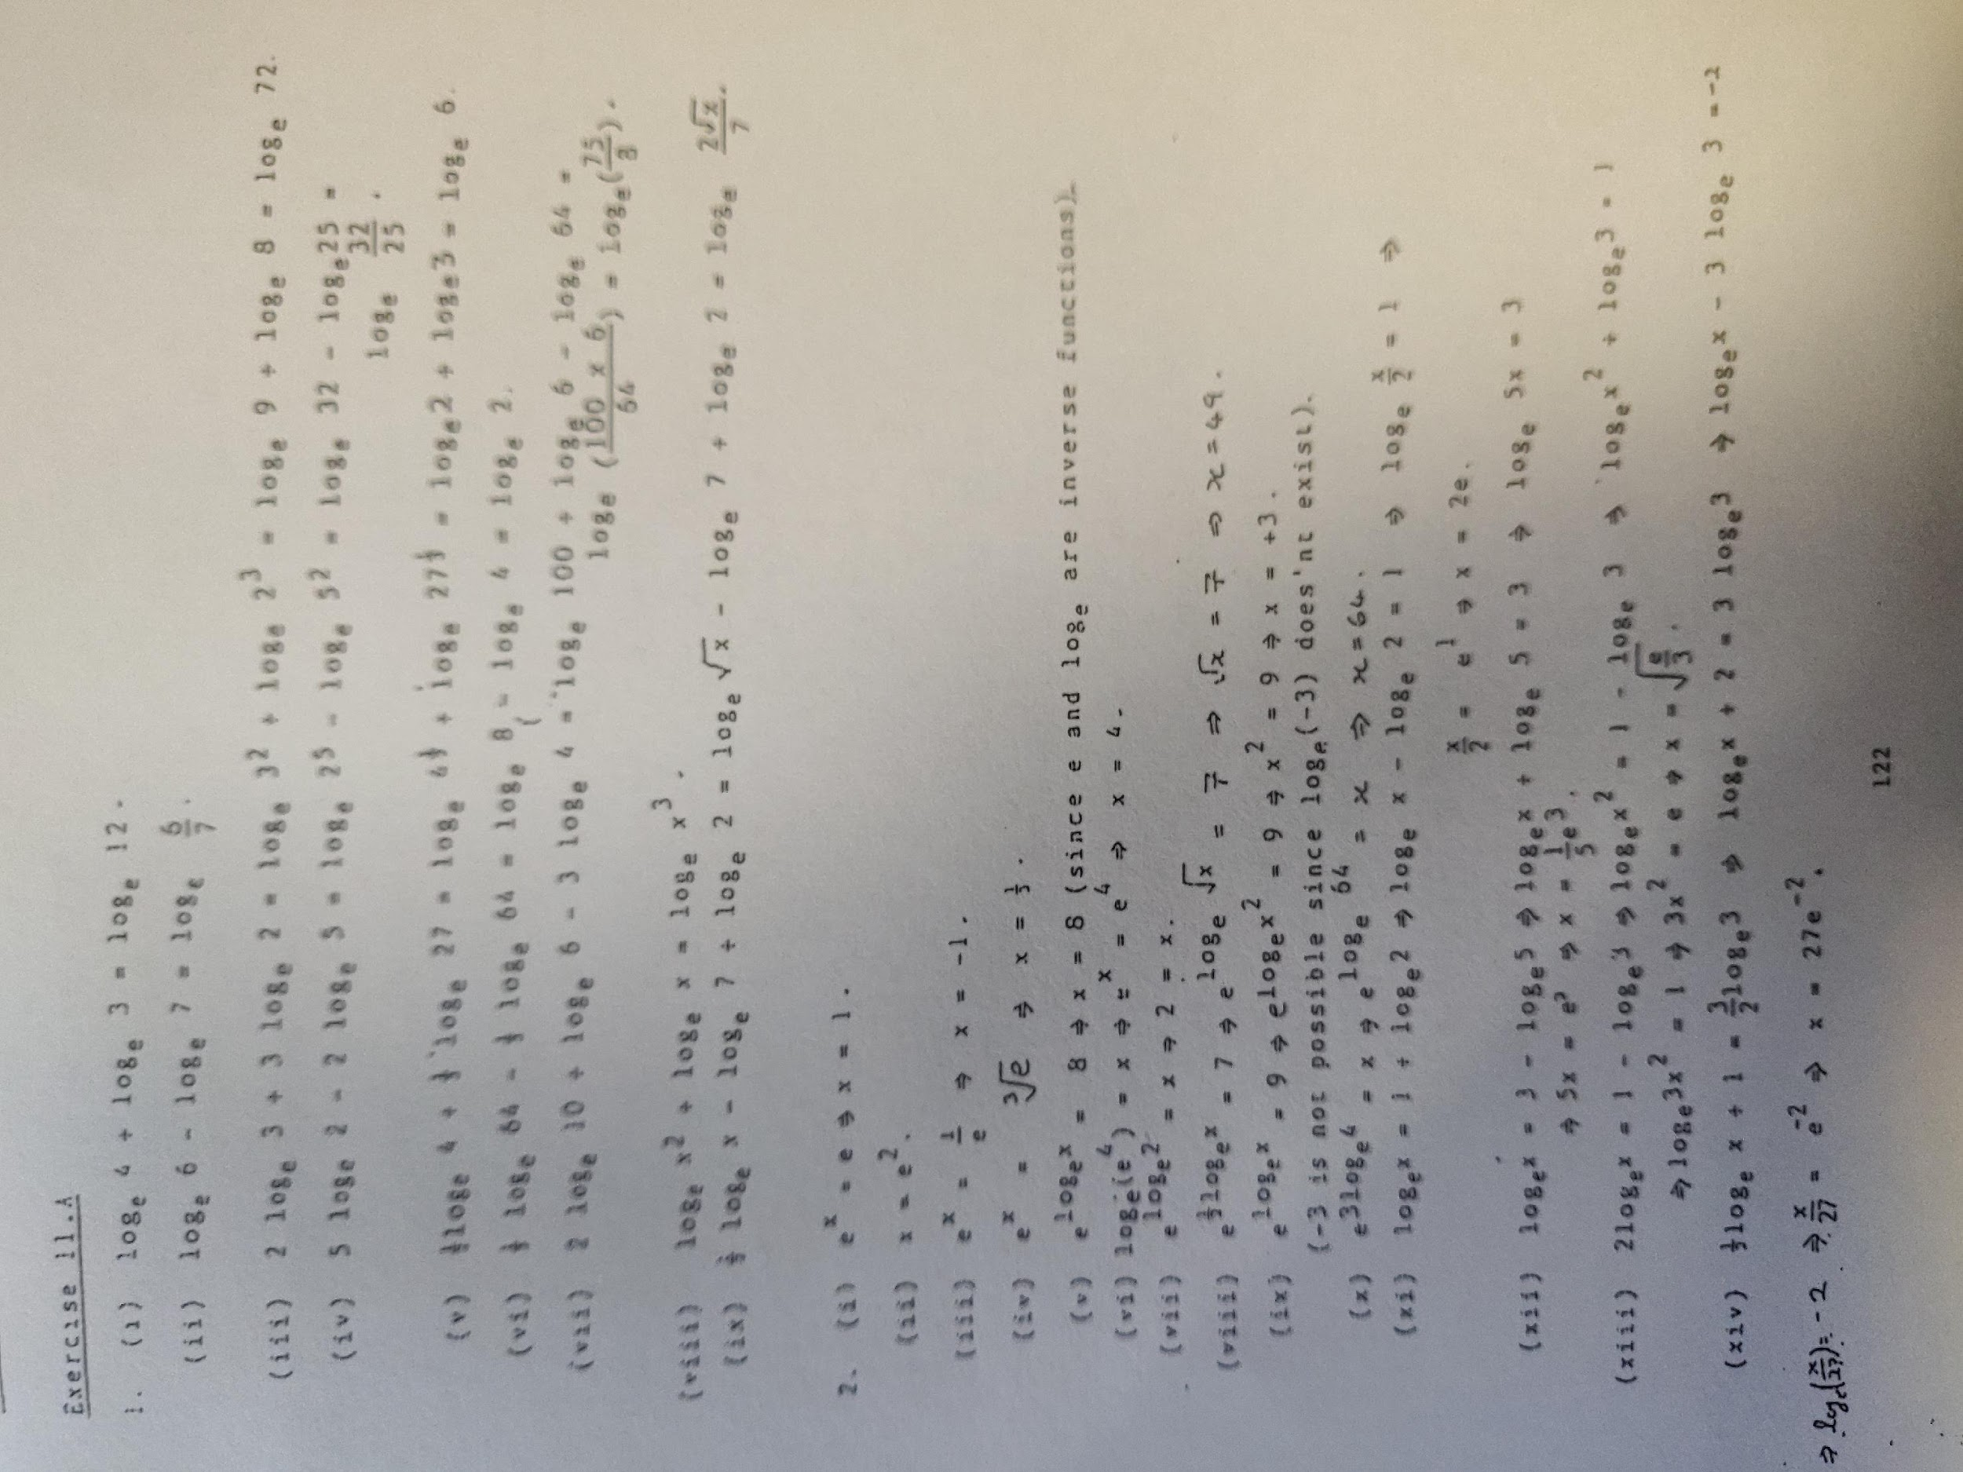

Merry X-mas

Can you get from the first line to the last without looking at the solution?

$$y=\frac{ln⁡(\frac{x}{m}-sa)}{r^{2}}$$

$$yr^{2}=\frac{x}{m}-sa)$$

$$e^{{yr}^{2}}=\frac{x}{m}-sa$$

$$e^{{yr}^{2}}+sa=\frac{x}{m}$$

$${m(e}^{{yr}^{2}}+sa)=x$$

$${me}^{{yr}^{2}}+msa=x$$

$${me}^{{yr}^{2}}=x-msa$$

$${me}^{rry}=x-mas$$

Integration

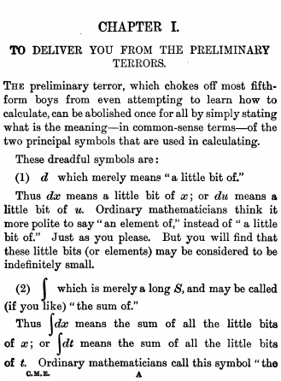

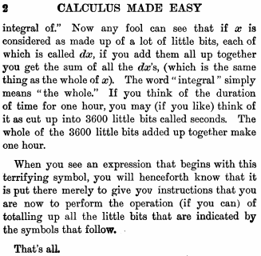

From http://djm.cc/library/Calculus_Made_Easy_Thompson.pdf

$$life=\int_{birth}^{death}{}\frac{happiness}{time}∆time$$

Revision of integration

Commonly asked integrals

Those in bold can be found on page 26 of the ‘Formula and Tables’ book | Examples
$$\int{}x^{n}dy=+C$$ | $$\int{}x^{3}dy=+C$$
$\int{}\frac{1}{y^{2}}dy=\int{}y^{-2}dy=+C$ = $-\frac{1}{y}+C$

$$\int{}\frac{1}{x}dx=lnln x+C$$

$$\int{}e^{x}dx=e^{x}+C$$

$$\int{}e^{ax}dx=\frac{1}{a}e^{ax}+C$$ | $$\int{}e^{2x}dx=\frac{1}{2}e^{2x}+C$$
$$\int{}coscos x dx=sinsin x +C$$

$$\int{}sinsin x dx=-coscos x +C$$

$$\int{}coscos ax dx=\frac{1}{a}sinsin ax +C$$ | $$\int{}coscos 4x dx=\frac{1}{4}sinsin 4x +C$$
$$\int{}sinsin ax dx=-\frac{1}{a}coscos ax +C$$ | $$\int{}sinsin 6x dx=-\frac{1}{6}coscos 6x +C$$
$$\int{}sinsin (ax+b) dx=-\frac{1}{a}coscos (ax+b) +C$$

$$\int{}\frac{1}{x^{2}+a^{2}}dx=\frac{1}{a}\frac{x}{a} +C$$ | $$\int{}\frac{1}{9+x^{2}}dy=\frac{x}{3} +C$$
$$\int{}\frac{1}{1+x^{2}}dx=x +C$$

$$\int{}\frac{1}{a^{2}-x^{2}}dx=\frac{x}{a} +C$$ | $$\int{}\frac{1}{25-x^{2}}dx=\frac{x}{5} +C$$

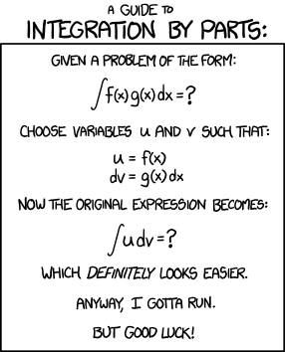
http://xkcd.com/1201/

Reminds me of this one

Exam questions: Part ‘a’s
Note
- Separating the variables: Before integrating you will need to have all terms involving x (and dx) on one side and terms involving y (and dy) on the other.

- Ensure that dy and dx are ‘above the line’ on their respective sides.
- To do this you may need to first add fractions and if necessary take out common factors.
- Generally when the question says ‘solve’, the convention is to solve for the variable on top (usually y). Another way of saying this is: “get an expression for y in terms of x”

- Note that for all of these you use limits or constants.
If using constants you will need to use the following:
If the constant on the left hand side is C₁ and the constant on the right hand side is C₂, you can replace the constant on the right hand side by C₃, where C₃ = C₂ – C₁ (because we never actually need to know the value of C₁ or C₂, just the value of C₂ – C₁.
- The question given in 2001 (a) shouldn’t have been asked – it required knowledge of a concept in maths that is not and was not on the leaving cert maths syllabus. So just write it off as an aberration.

2022 Deferred (a)

- Solve the differential equation $(1+t^{2}$)$\frac{dr}{dt}$ = 1 given that $r=0$ when $t=\frac{π}{4}$.

- If $\frac{dy}{dx}=(y+4)\cos^{2}{3x}$ and $y=-3$ when $x=0$, find the value of y when $x=\frac{π}{6}$.

2018 (a)
If $\frac{dy}{dx}$= 3 sin 3x + cos 5x and y = 1 when x =, find the value of y when x = 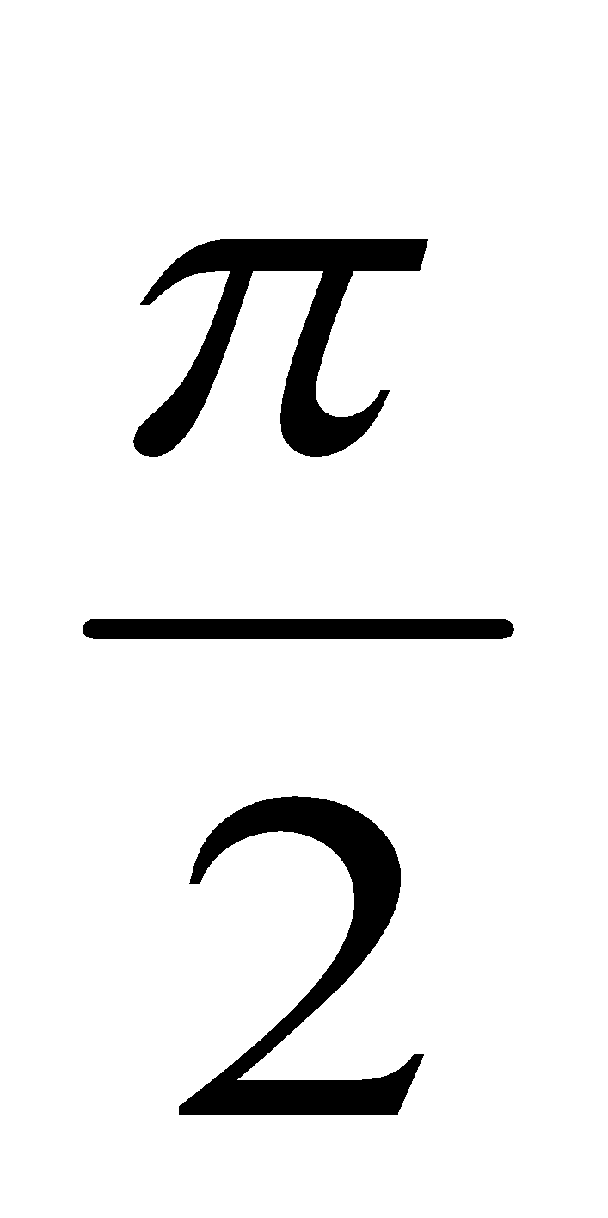.
Give your answer correct to 2 decimal places.

2013 (a)
If $x^{2}\frac{dy}{dx}-7=0$ and y = 1 when x = 7, find the value of y when x =14.

2011 (a)
If $x^{2}\frac{dy}{dx}$ - xy = 7y and y = 1 when x = 1, find the value of y when x = 2.

2008 (a)
If 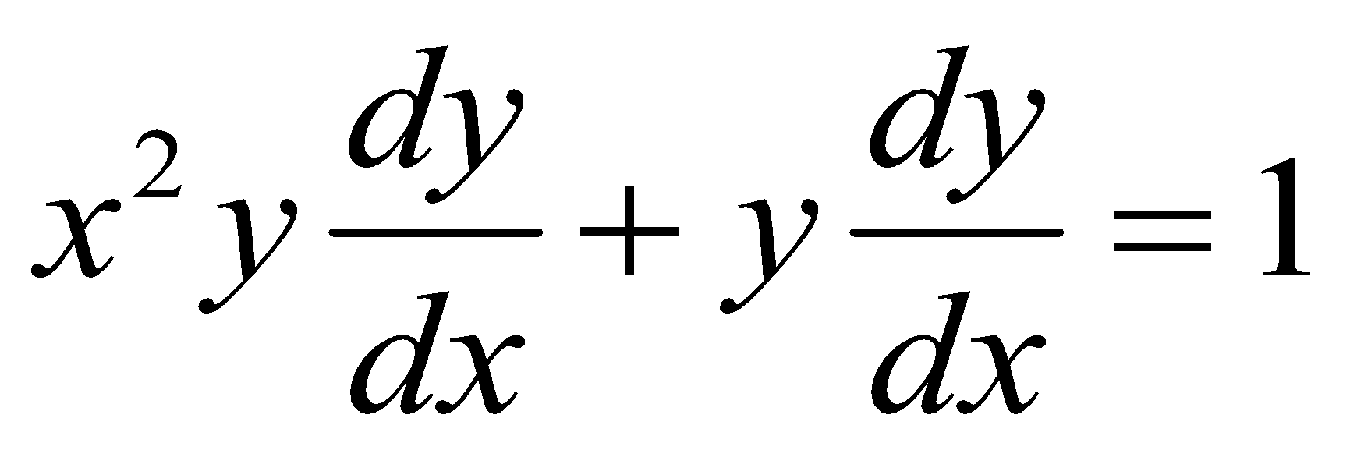 and y = 0 when x = 0, find the value of x when 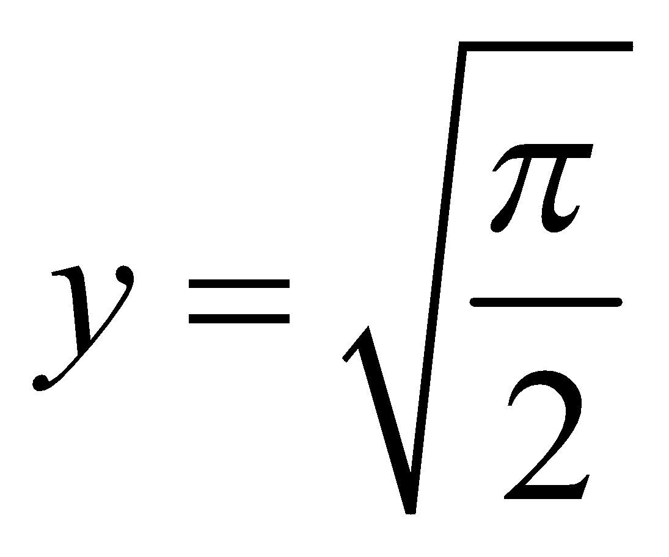

2007 (a)
Solve the differential equation 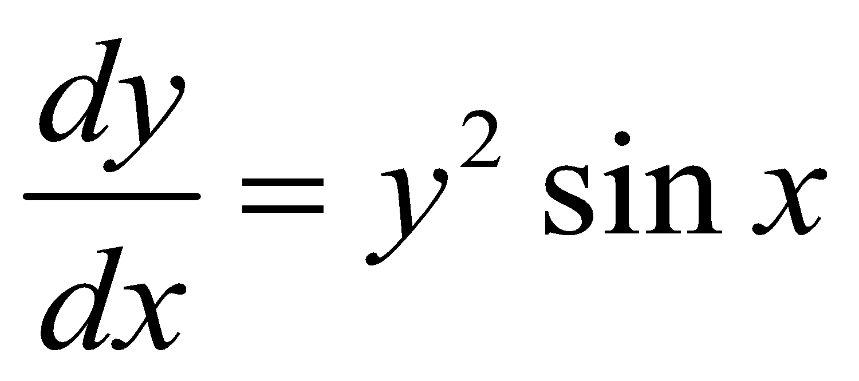 given that y = 1 when x = π/2

2005 (a)
Solve the differential equation 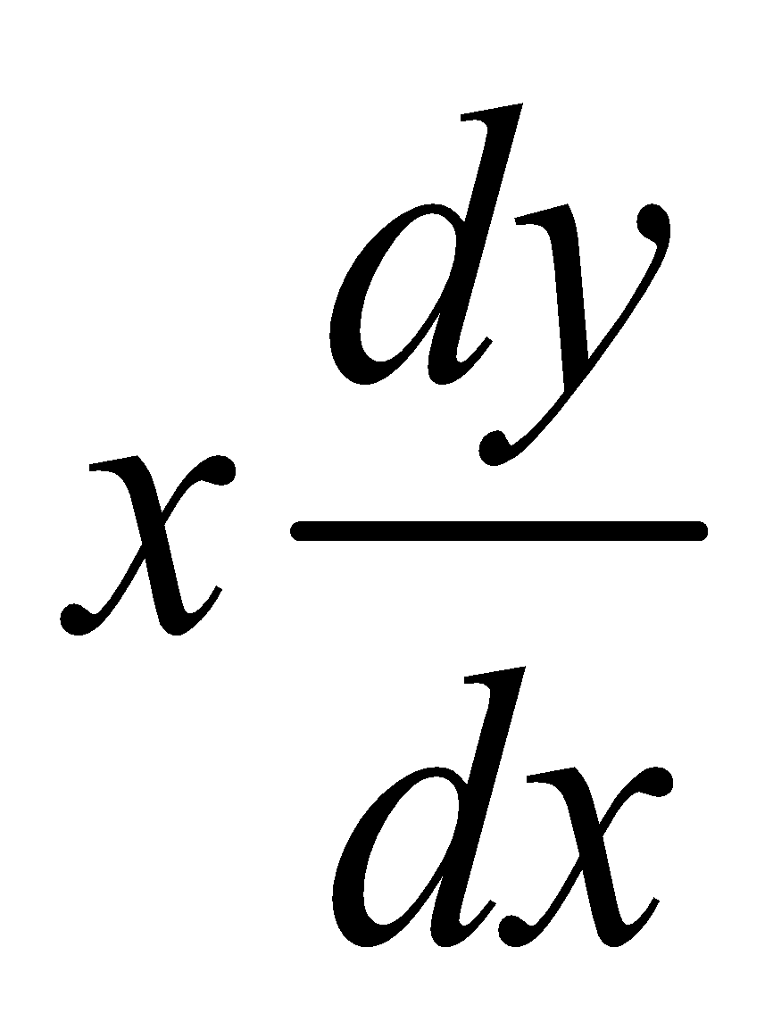– xy – y = 0 given that y = 1 when x = 1.

2004 (a)
Solve the differential equation 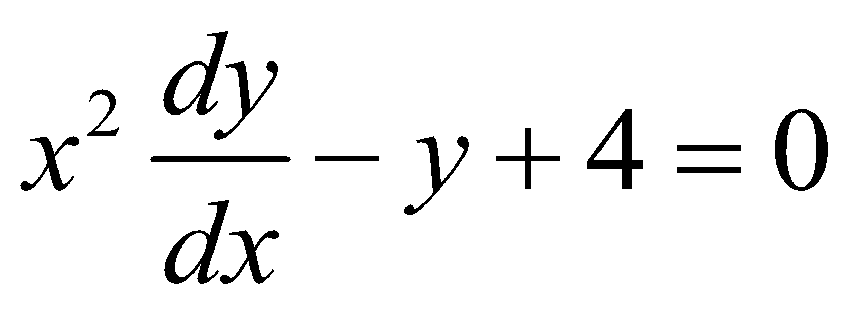 given that y = 5 when x = 1.

2002 (a)
Solve the differential equation 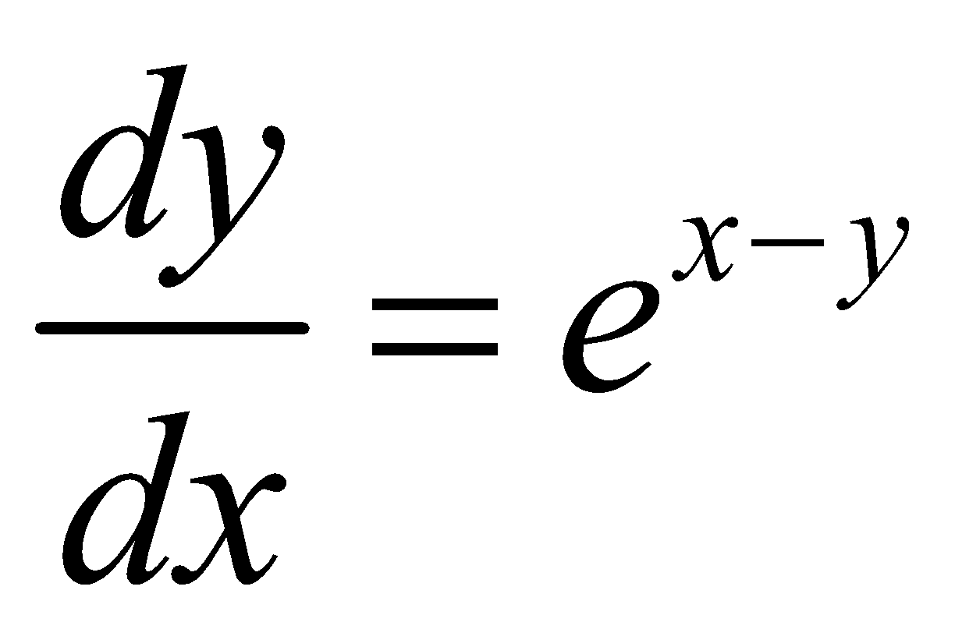 given that y = ln 4 when x = 0.

2000 (a)
If 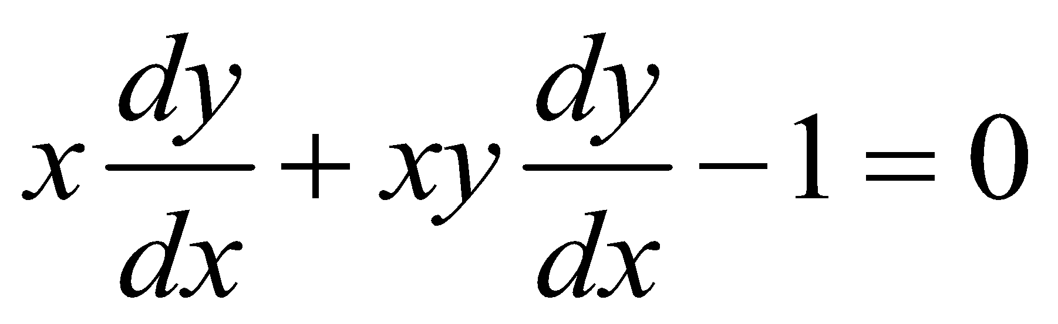 and y = 2 when x = e, find, correct to two places of decimals, the positive value of y when x = e².

1999 (a)
Solve the differential equation $\left(\frac{7}{v^{2}+1}\right)\frac{dv}{dx}=\frac{1}{x}$ given that v = 0 when x = 1.

1998 (a)
If $t\frac{dv}{dt}=v-vt$ and v = 3 when t = 5, find the value of v when t = 6.

1997 (a)
If 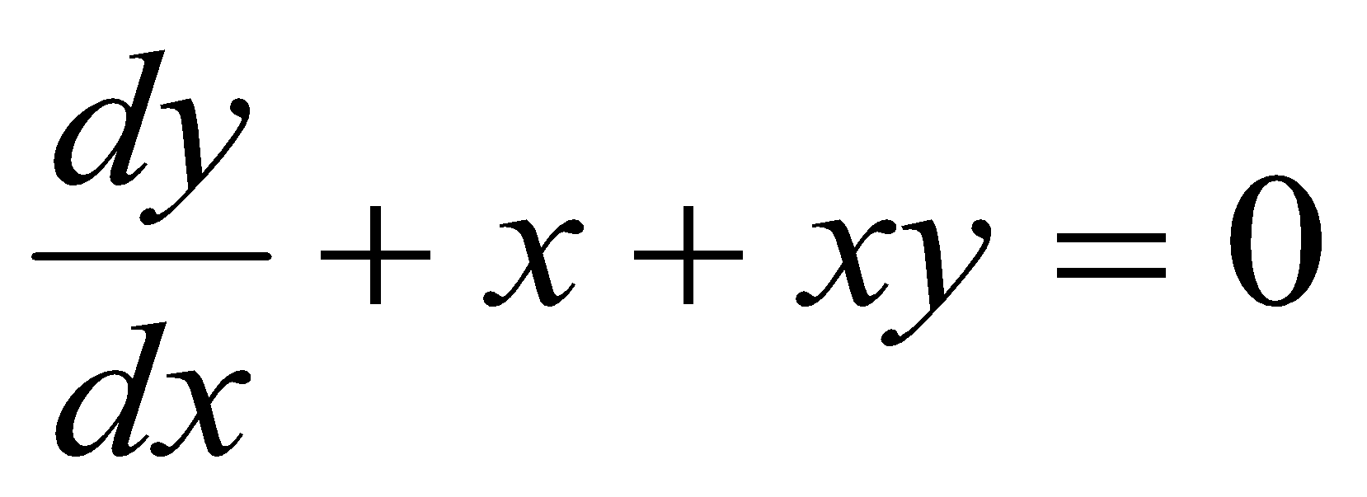 and y = 2 when x = 0, find, correct to two places of decimals, the value of y when x = 1.

1996 (a)
Solve the differential equation 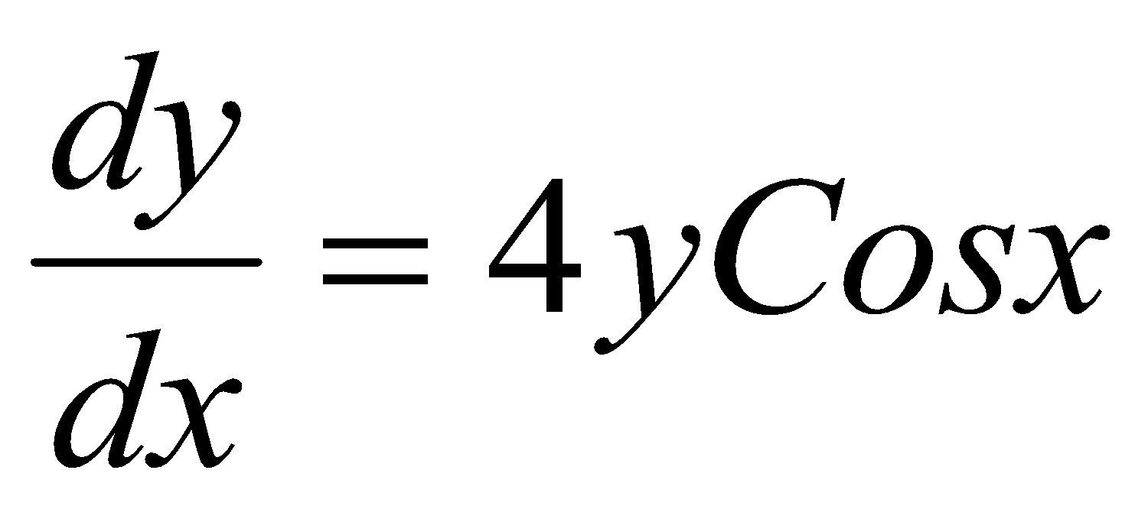 if y = e² when 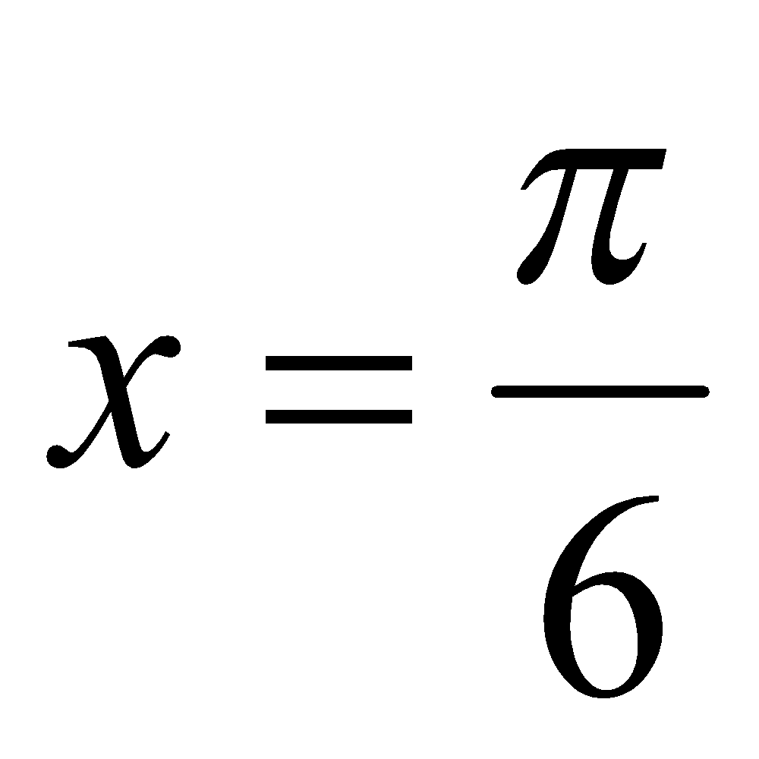

1995 (a)
Solve the differential equation 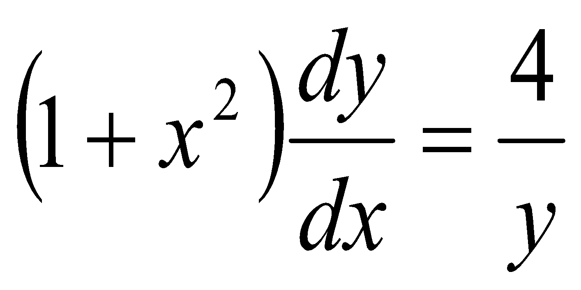 if x = 0 when y = 1.

1992 (a)
If 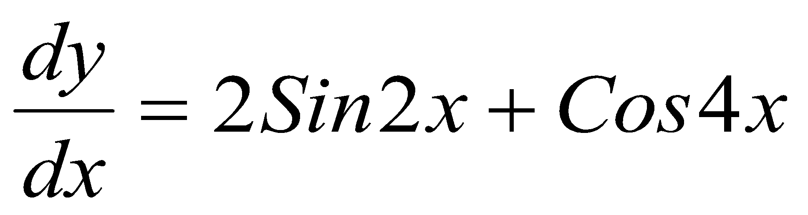 and if y = 1 when x =, find the value of y when x = .

1989 (a)
Find the solution of the differential equation 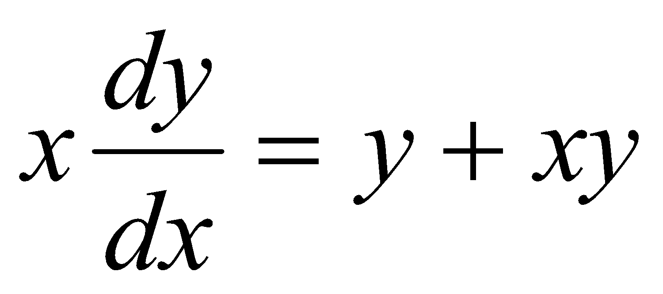 if y = 1 when x = 1.

1986 (a)
Solve the differential equation 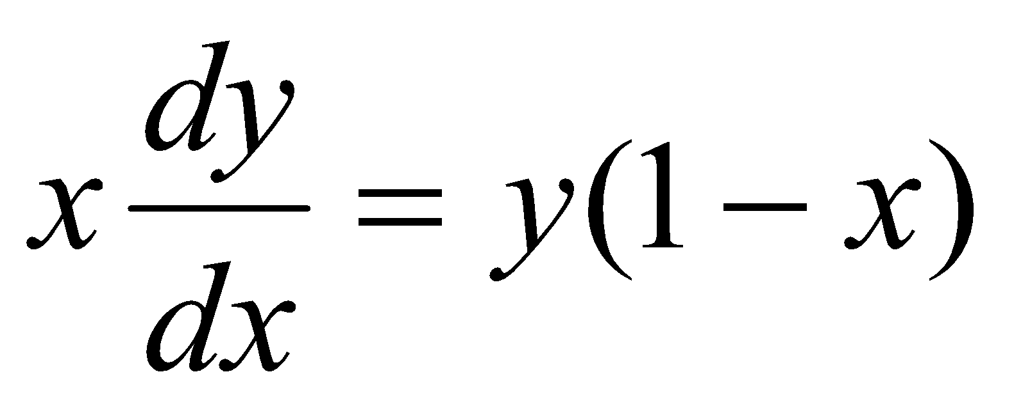 if y = 3 when x = 1.

1983 (a)
Find the solution of the differential equation $sinsin x \frac{dy}{dx}=ycoscos x$ when y = 2 at x = .

1988 (a) - tricky!
Solve the differential equation 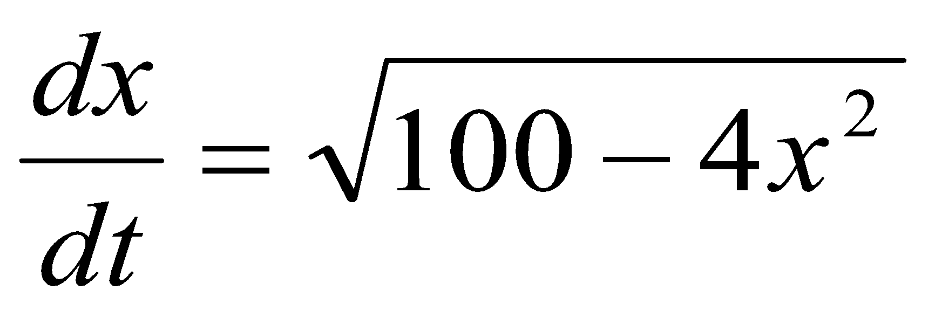 if x = 5 when t = 0.

1994 (a) – tricky!
Solve the differential equation 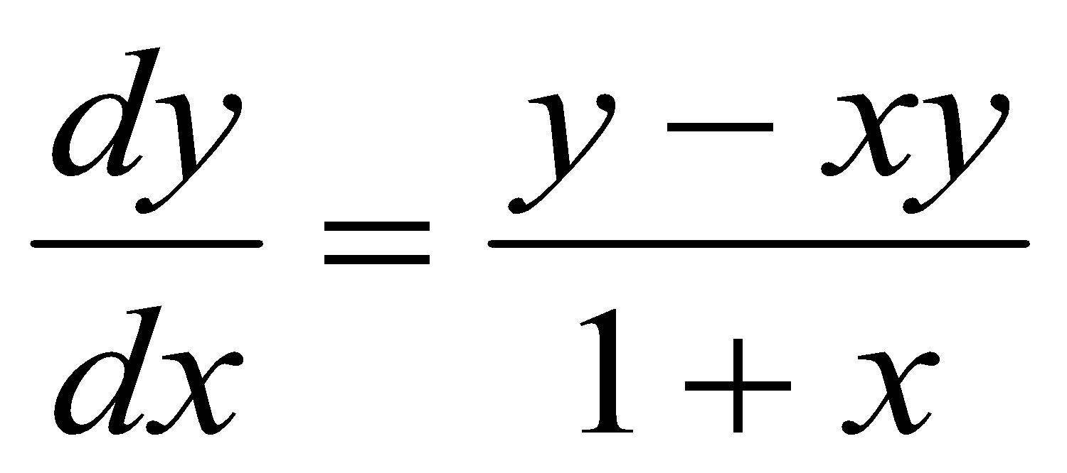 if y = 1 when x = 0.

Integration by substitution

Note that from 2012 (when it was taken off the Higher Maths course) to 2022 (after which the syllabus changed again), questions did not require you to know how to use ‘integration by substitution’.
I have included all questions here, regardless of whether or not they require use of this technique.
Example 1
Use the method of integration by substitution to show that

Solution
Let du=dx

Example 2
Use the method of integration by substitution to show that
Solution
Let du=dx

= = =

=

The expressions below can be obtained via integration by substitution
You should be familiar with them and be able to show how to obtain them.
Many of these are repetitive – I simply copied them from exam questions so those which come up the most often are obviously the ones you need to be most familiar with.

Most the examples below are variations on the following general rule: $\left(\int{}\frac{1}{a+bx}dx= \frac{1}{b}ln\left[a+bx\right]+c\right)$
 | Answer
$$\int{}\frac{1}{x+a}dx$$ | $$lnln (x+a)$$
$$-\int{}\frac{1}{x+a}dx$$ | $$(x+a)$$
$$\int{}\frac{1}{x-a}dx$$ | $$lnln (x-a)$$
$$\int{}\frac{1}{a-x}dx$$ | $$(a-x)$$
$$\int{}\frac{1}{ax+b}dx$$ | $$\frac{1}{a}lnln (ax+b)$$
$$\int{}\frac{x}{1+x^{2}}dx$$ | $$ln\frac{1}{2}ln (1+x^{2})$$
$$\int{}\frac{x}{1+x}dx$$ | $$1+x-lnln (1+x)$$
$$\int{}\frac{1}{a+bx} dx$$ | $$\frac{1}{b}ln\left[a+bx\right]$$
$$\int{}\frac{x}{1+x^{2}}dx$$ | $$ln\frac{1}{2}ln (1+x^{2})$$
$$\int{}\frac{v}{v^{2}+{80}^{2}}dx$$ | $$ln\frac{1}{2}ln (v^{2}+{80}^{2})$$
$$\int{}\frac{y}{1+y^{2}}dy$$ | $$ln\frac{1}{2}ln (1+y^{2})$$
$$\int{}\frac{x}{1+x}dy$$ | $$1+x-lnln (1+x)$$
$$\int{}\frac{x}{2x^{2}-3}dx$$ | $$\frac{1}{4}lnln ( 2x^{2}-3)$$
$$\int{}\frac{x}{x^{2}+2}dx$$ | $$\frac{1}{2}lnln ( x^{2}+2)$$
$$\int{}\frac{y^{2}}{1+y^{3}}dx$$ | $$ln\frac{1}{3}ln (1+y^{3})$$
$$\int{}\frac{1}{g-kv}dv$$ | $$-ln\frac{1}{k}ln (g-kv)$$
$$\int{}\frac{1}{100-v}dv$$ | $$-lnln (100-v)$$
$$\int{}\frac{v}{100-v}dv$$ | $$-\left(100-v\right) +(100-v)$$
$$\int{}\frac{v}{5-v^{2}}dv$$ | $$(5-v^{2})$$
$$\int{}\frac{v}{0.12-{0.006v}^{2}}dv$$ | $$-ln\frac{1}{2}ln (0.12-{0.006v}^{2})$$
$$\int{}\frac{1}{g-kv}dv$$ | $$-\frac{1}{k}lnln (g-kv)$$
$$\int{}\frac{dt}{9900t+1}$$ | $$\frac{1}{9900}lnln \left(9900 t+1\right) + C$$
$$\int{}\frac{dv}{a-v}$$ | $$(a-v)$$
$$\int{}\frac{v}{g+kv^{2}}dv$$ | $$\frac{1}{2k}lnln (g+kv^{2})$$
$$\int{}\frac{v}{g-kv^{2}}dv$$ | $$-\frac{1}{2k}lnln (g-kv^{2})$$
$$\int{}\frac{dx}{a+bx}$$ | $\frac{1}{b}$ln|𝑎+𝑏𝑥 |+𝑐
$$\int{}\frac{v}{g+{kv}^{2}}dv$$ | $$ln\frac{1}{2k}ln (g+kv^{2})$$
$$\int{}\frac{1}{g+{kv}^{2}}dv$$ | $$\left(\frac{v}{\sqrt{\frac{g}{k}}}\right)$$
$$\int{}\frac{v}{g+kv^{2}}dv$$ | $$\frac{1}{2k}lnln (g+kv^{2})$$
$$\int{}\frac{7v}{900-v^{2}}dv$$ | $$-\frac{7}{2}lnln (900-v^{2})$$
$$\int{}\frac{2v}{150-3v}dv$$ | $$-\frac{2}{3}v-\frac{100}{3}lnln (150-3v)$$
$$\int{}\frac{500v^{2}}{8000-v^{3}}dv$$ | $$-\frac{500}{3}lnln (8000-v^{3})$$
$$\int{}\frac{v}{v-6}dv$$ | $$6lnln \left(v-6\right) +(v-6)$$

Questions requiring integration by substitution

2010 (a)
Solve the differential equation given that y = 0 when x = 0

2009 (a)
Solve the differential equation $\frac{dy}{dx}=\frac{1}{xy}+\frac{y}{x}$ given that y = √3 when x =1.

2006 (a)
Solve the differential equation 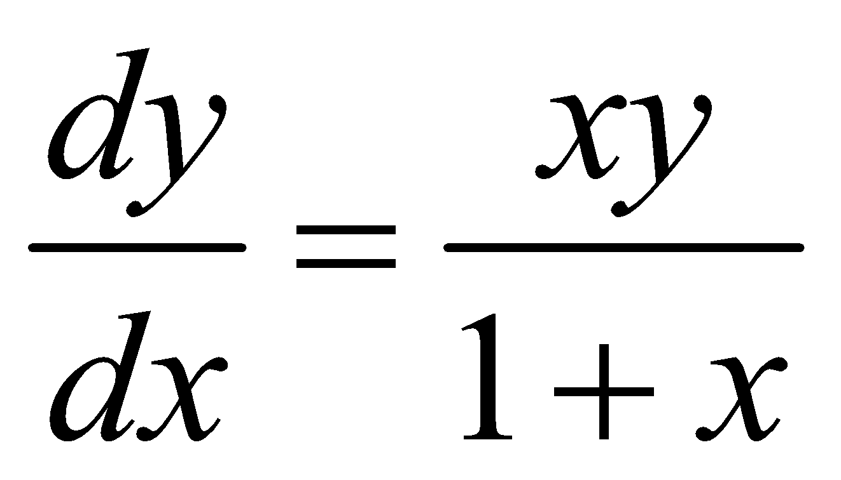 given that y = e when x = 0.

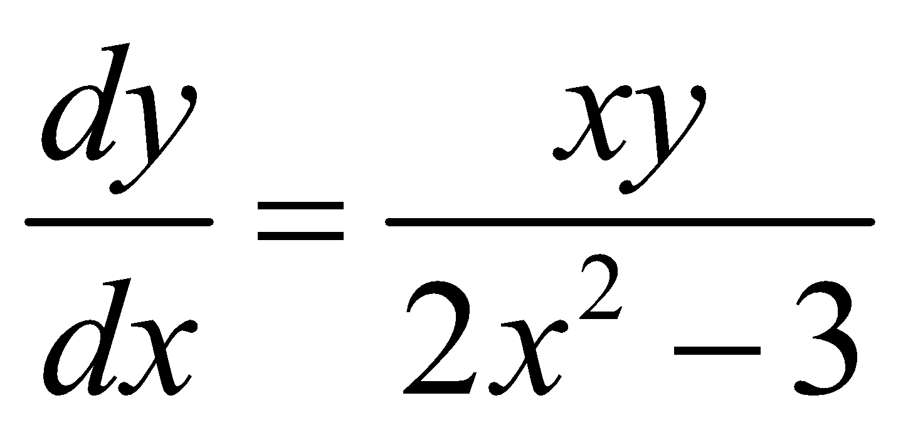
2003 (a)
Solve the differential equation given that y = 1 when x = √2.

1993 (a)
If 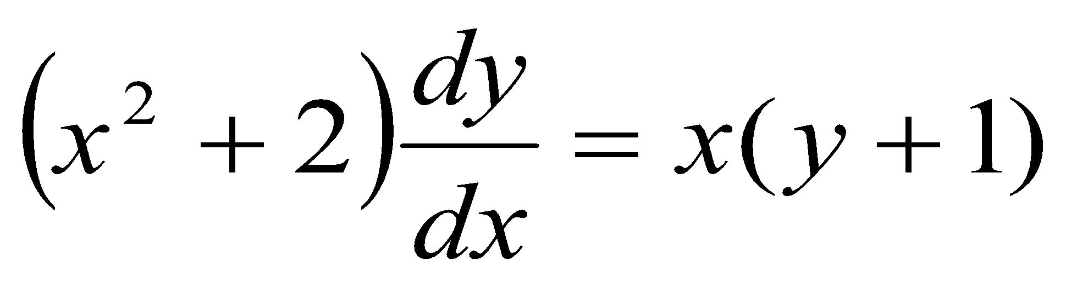 and y = 2 when x = 1, find the value of y when x = 2.

1991 (a)
Solve the differential equation 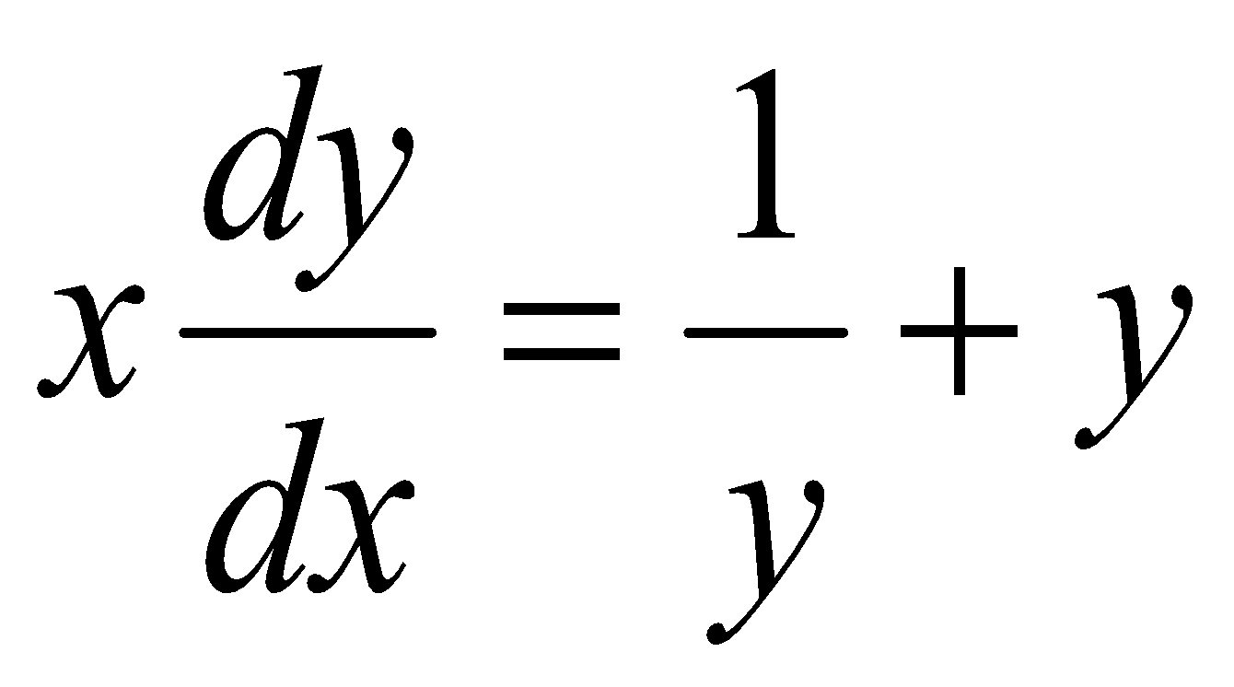 if y = 1 when x = 1.

1987 (a)
Solve the differential equation 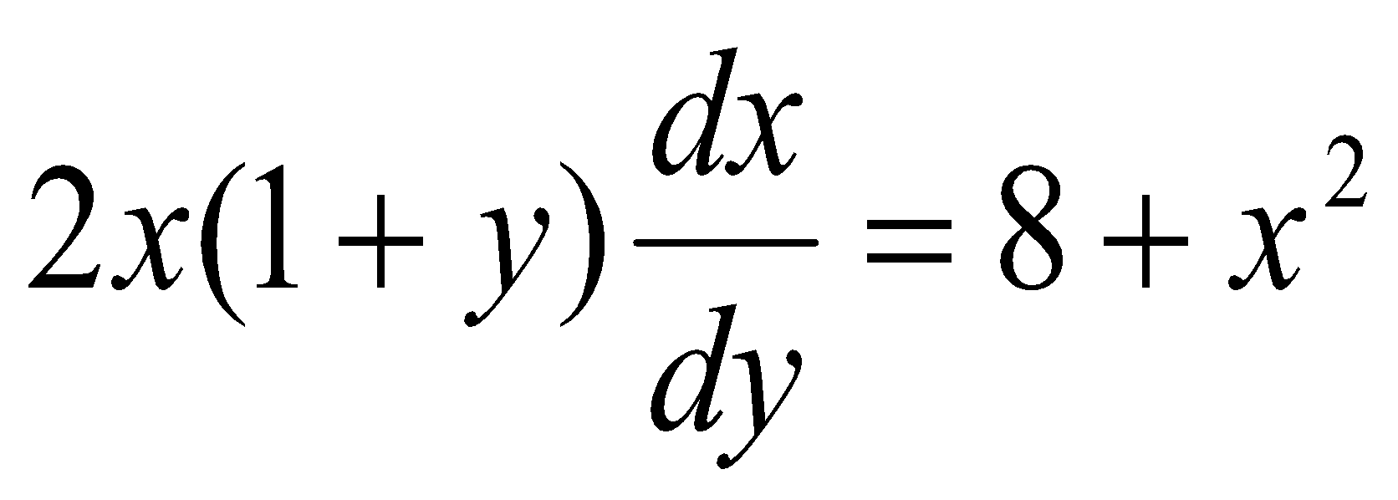 if x = 2 when y = 3

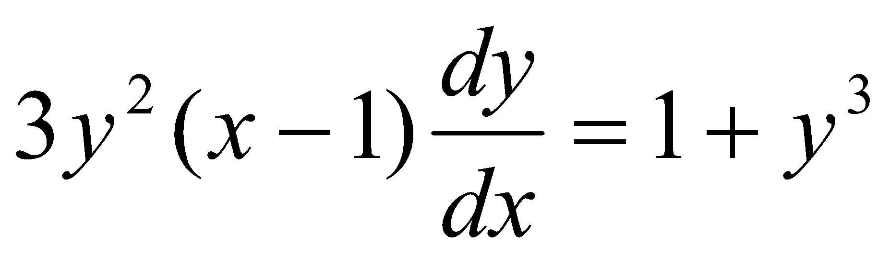
1985 (a)
Find the solution of the differential equation if y = 0 when x = 2.

1984 (a)
Find the general solution to 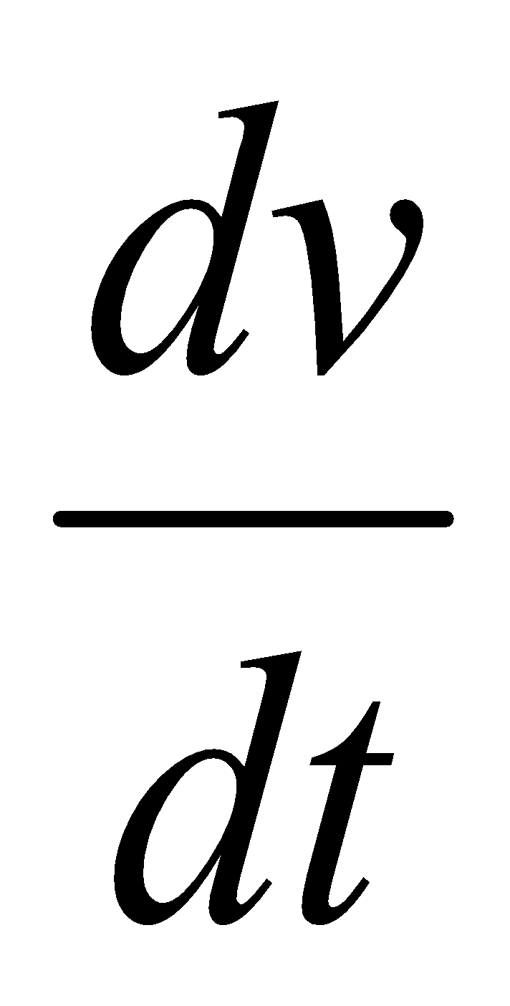= g – kv where g and k are constants. Show that lim v 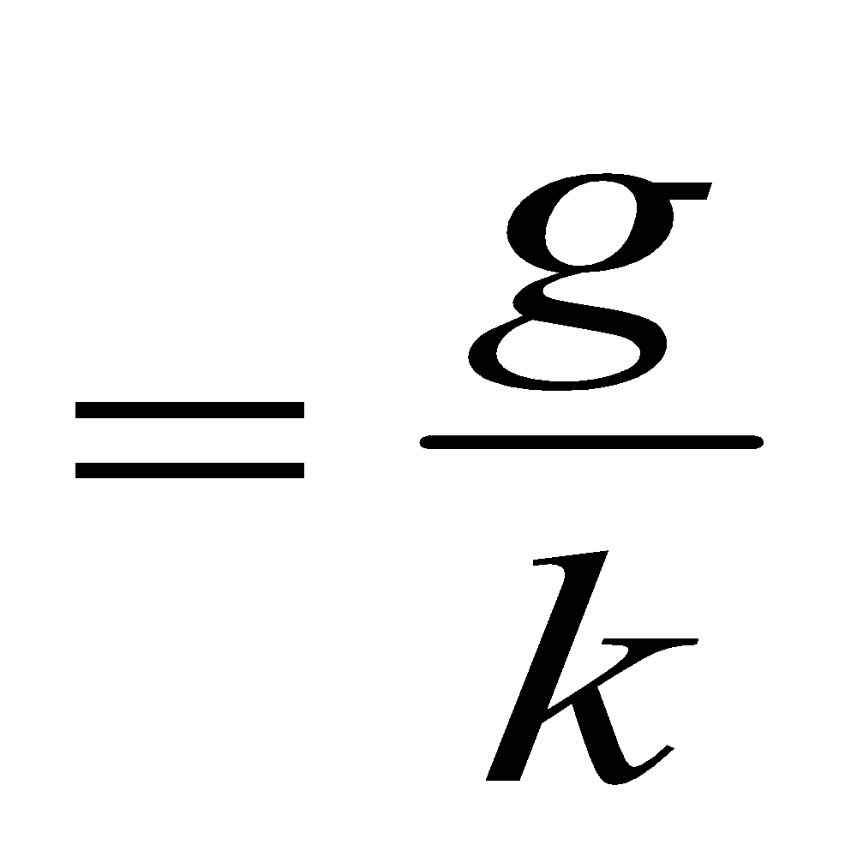

1982 (a)
- Find the solution of the differential equation 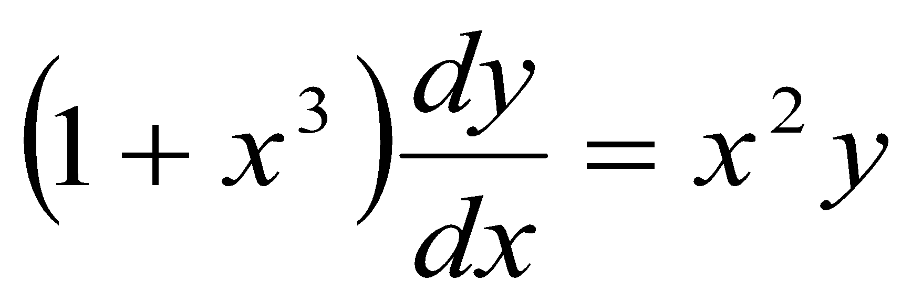 when y = 2 at x = 1.

1990 (a) – tricky!
Solve the differential equation 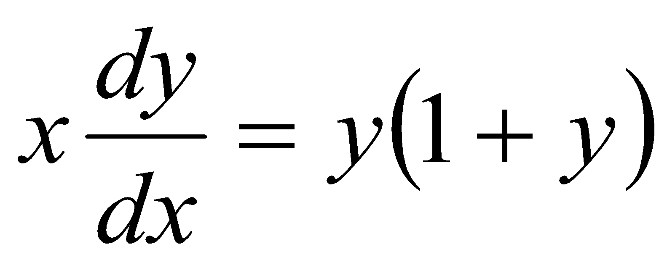 if x = 1 when y = 1.

1981 (a) – tricky!
Solve the differential equation 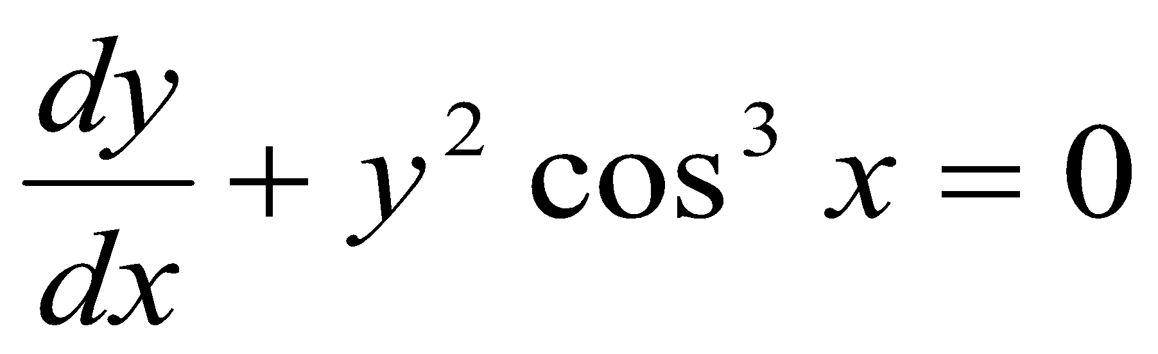 given that y = 2 when x = ^{π}/₆

Second order differential equations

Each of the following involve a second order differential equation.
Example: 1982 (a) (ii)
Find the solution of the differential equation when = 1 at t = 0 and s = 0 at t = 0.

To solve you need to proceed as follows:
Let This means

The question now becomes: when v = 1 at t = 0 and s = 0 at t = 0.

Solve as normal to get But , therefore

Proceed as normal to solve for s

1980 (a)
Solve the differential equation 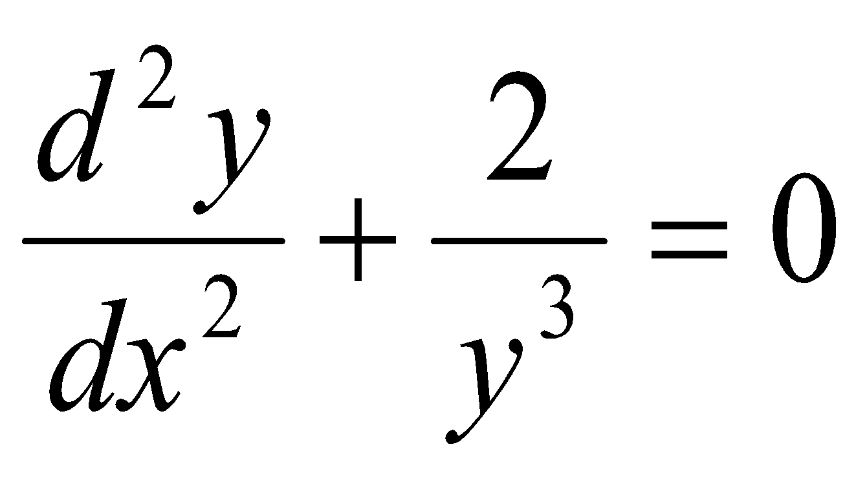 given that 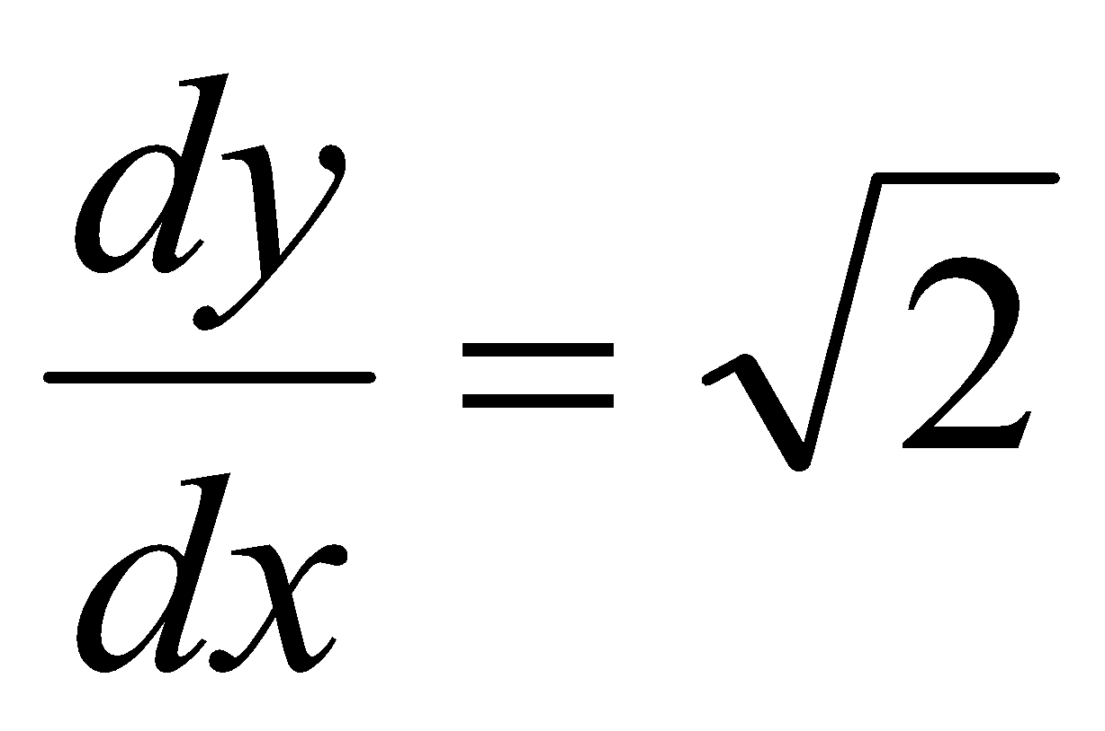 and x = 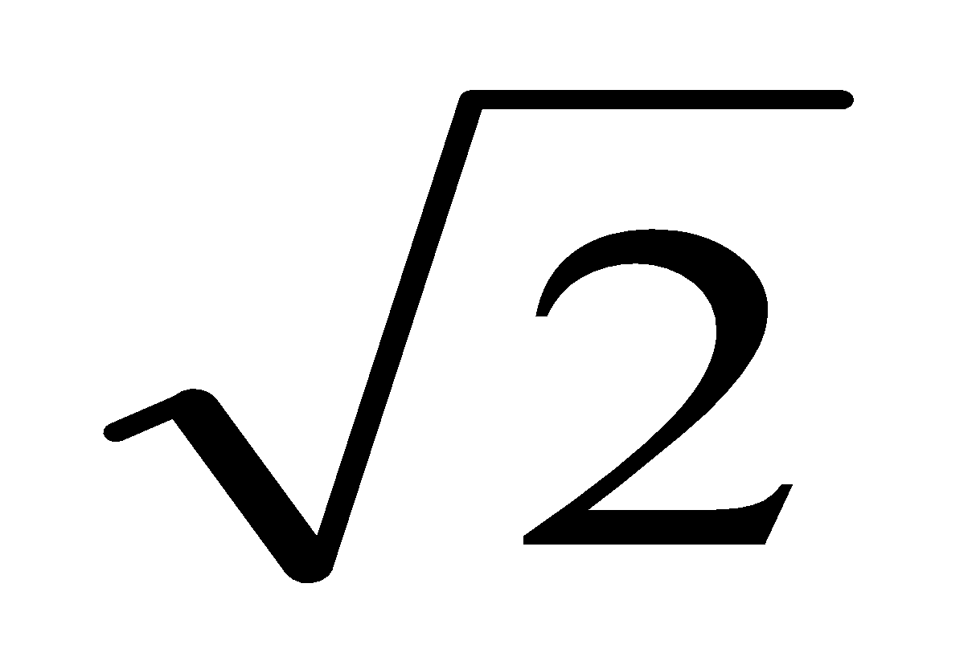 when y = 1.

1977
- Solve the differential equation 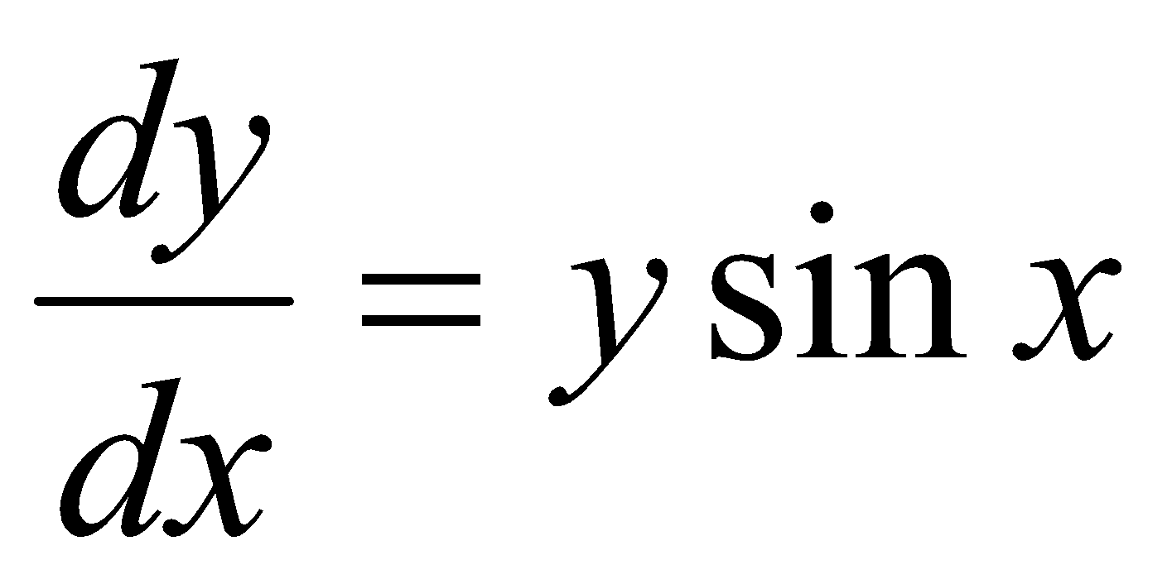 if y = 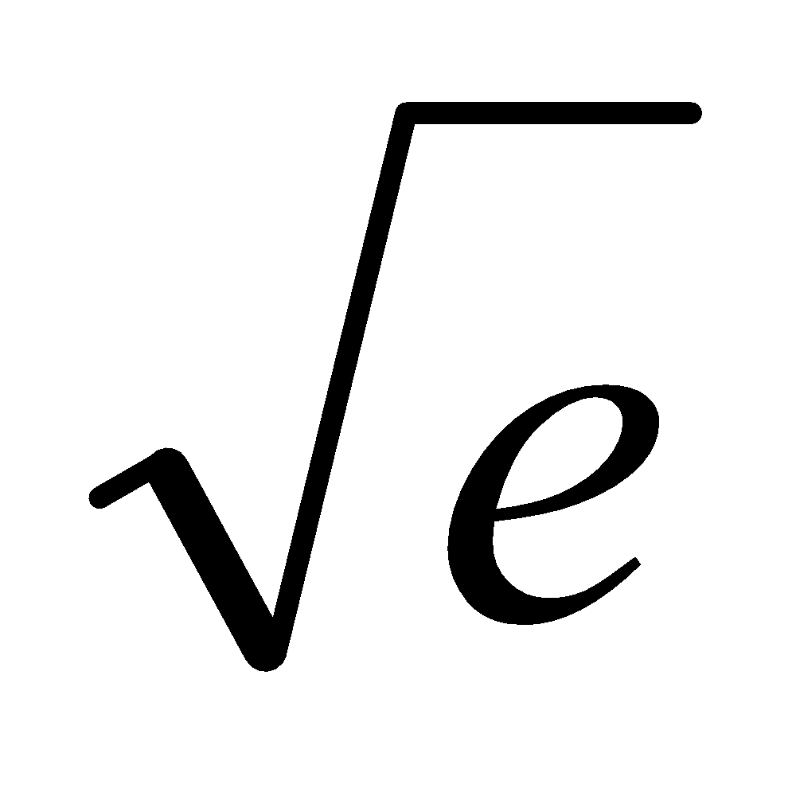 when x =
- Solve the equation 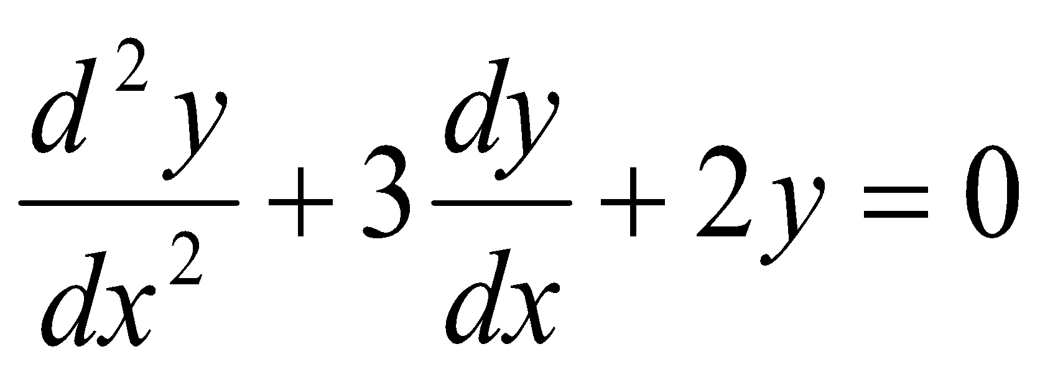 if y = 2 and 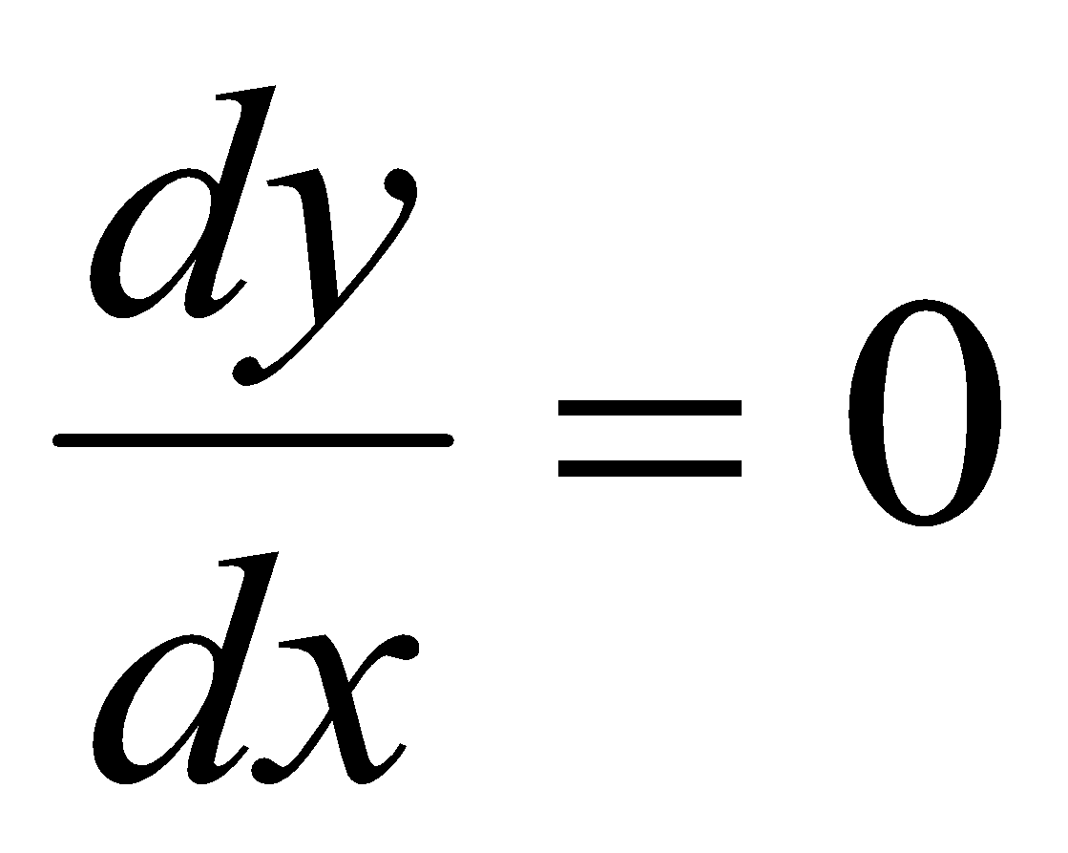 when x = 0.

1982 (b) (i)
Find the solution of the differential equation 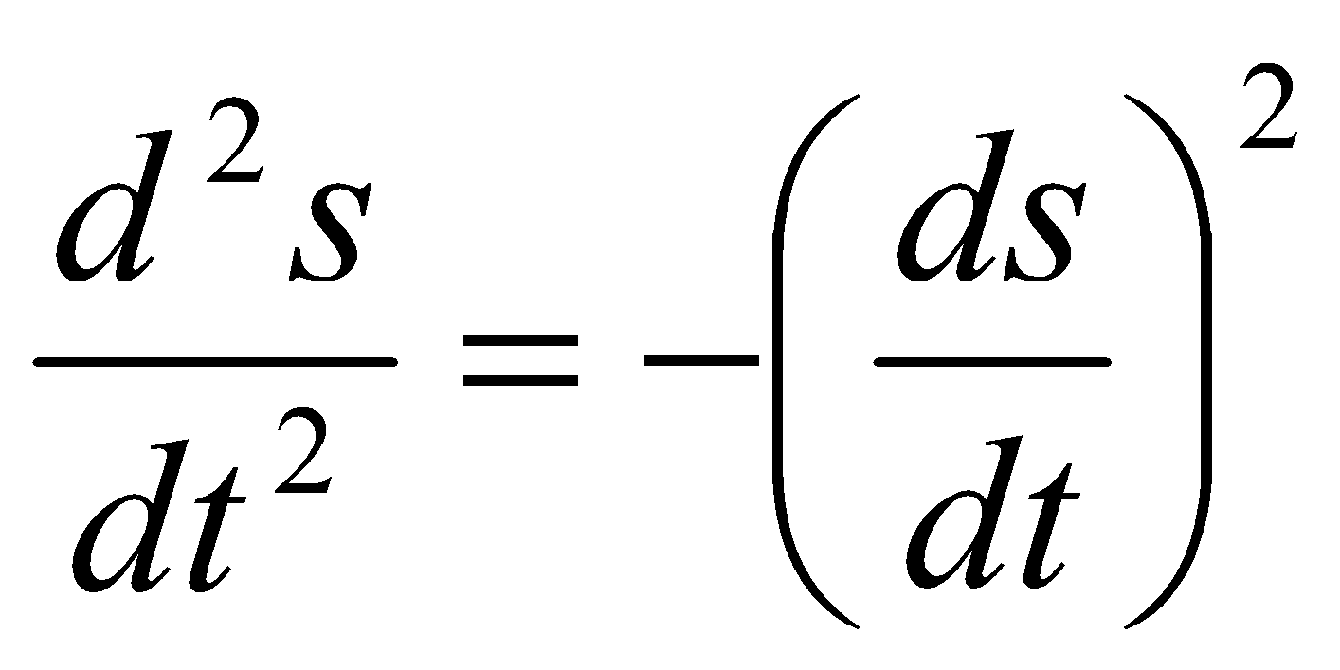when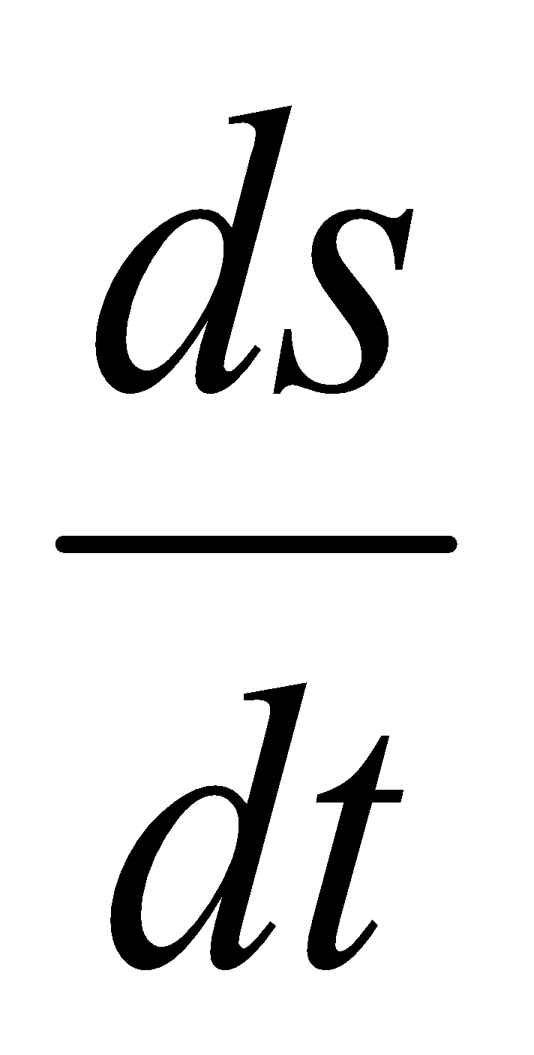 = 1 at t = 0 and s = 0 at t = 0.

1981 (b) (i)
Find the general solution to 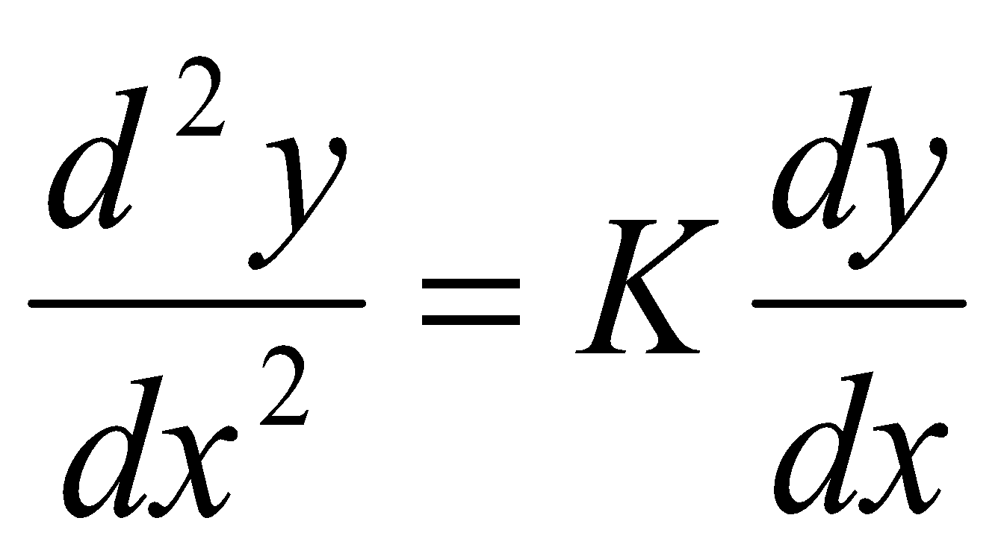 where K is a constant.

1979 (a)
Solve the differential equation 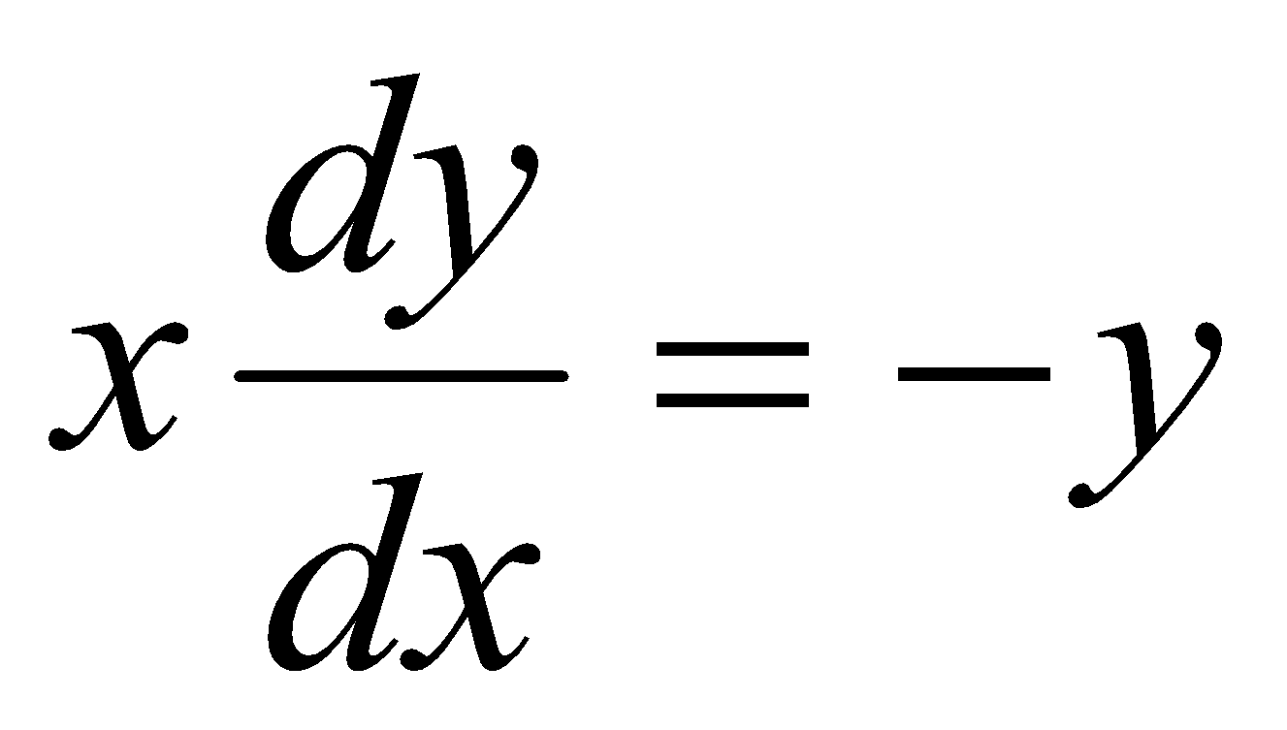 hence or otherwise solve 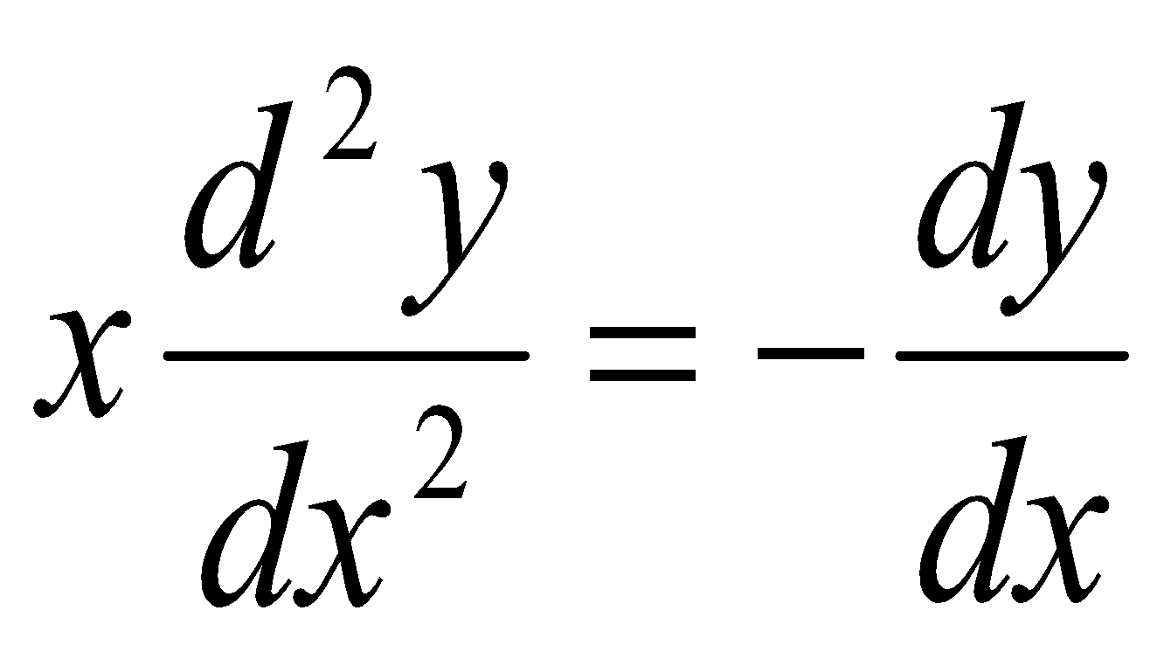
where y = 0 when x = 1 and y = 3 when x = e

1978 (a)
Solve the following differential equations:
- 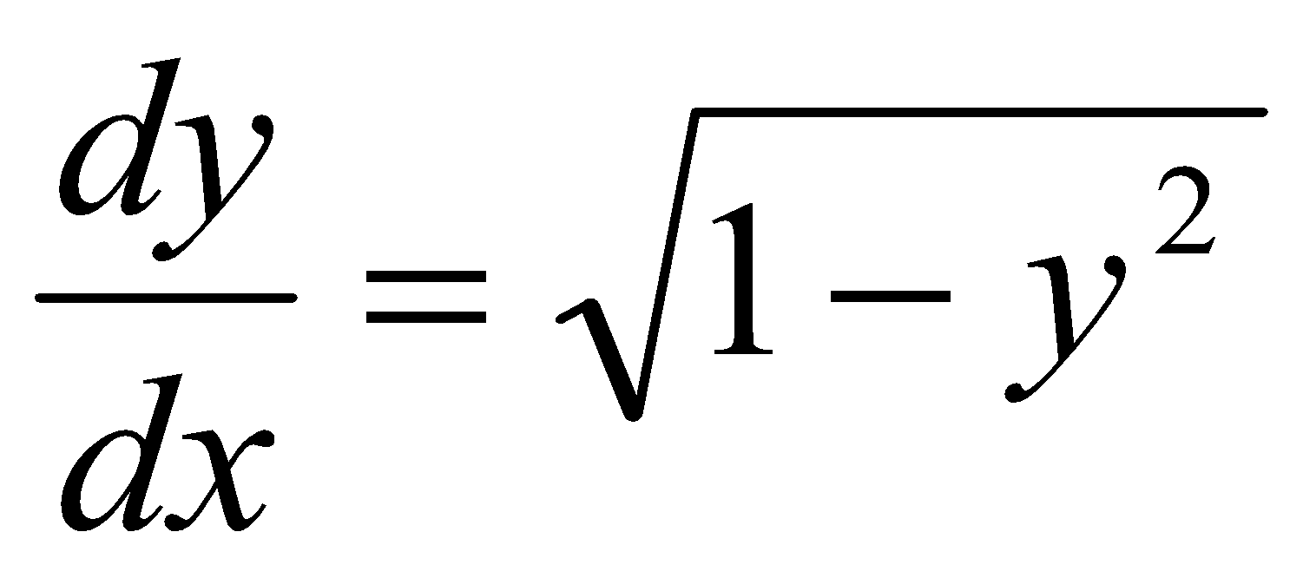 if y = 0 when x = 1
- 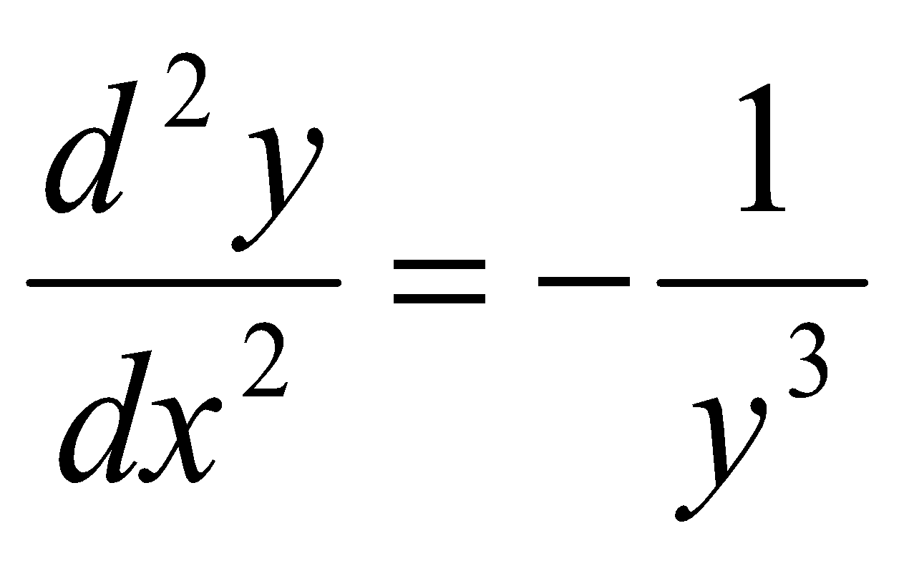 if 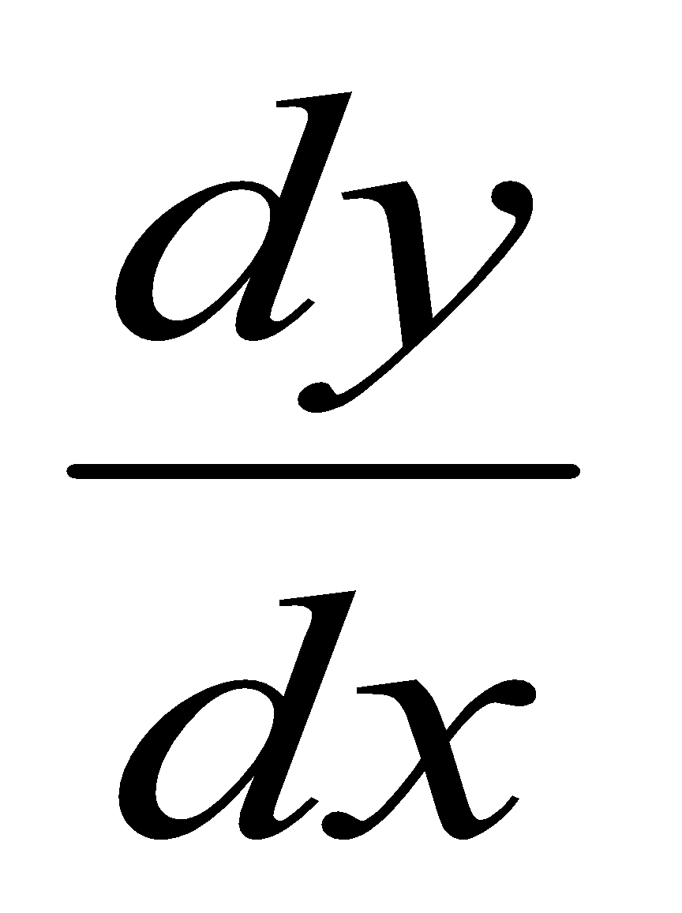= 1 and x = ½ when y = 1

Should I use constants of integration or limits?
It’s (slightly) interesting that the marking schemes usually use constants of integration for part (a) but tend to use limits of integration for part (b).
You can (almost always) use either.

So you know that the rate of change of displacement with respect to time is called velocity, and the rate of change of velocity with respect to time is called acceleration.
What about the rate of change of acceleration with respect to time?
Here’s a clue:
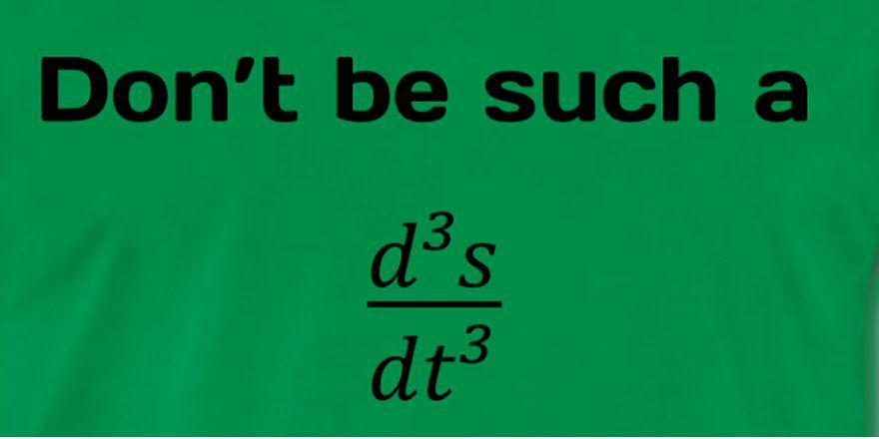

Motion expressed in terms of acceleration
For many questions we will use a = {links velocity and time}

But we may also need to link velocity and displacement.

To get an expression for this we do the following:
a =
a = {multiply above and below by ds}

a = {rearrange the terms above and below the line}

a = {because }

So we have two expressions for acceleration:

linking velocity and time | linking velocity and displacement
a = $\frac{dv}{dt}$ | $a=v\frac{dv}{ds}$

ALWAYS REMEMBER: IF IT CHANGES, INTEGRATE IT!!

Note: $Average speed= \frac{Total distance}{Total time}$

acceleration is proportional to the square of the speed

Here the term ‘retardation’ is used to mean ‘deceleration’

***********************************************************************************
a ∝ -v²
a = - k v²
Usually we can take one expression for a and use it to find k, then use the other expression for a to find what we’re looking for.

***********************************************************************************

1992 (b)
A particle experiences a retardation of kv m/s² when its velocity is v m/s. Its velocity is reduced from its initial value of 210 m/s to 70 m/s in 0.5 s and it travels a distance x m in this time.

- Find the value of k and deduce an expression for the velocity at any time t.
- Calculate the value of x.

1989 (b)
A cyclist, free-wheeling on a straight level road, experiences a retardation which is proportional to the square of his speed.
His speed is reduced from 6 m/s to 3 m/s in a distance of 35 m.
Show that the average speed during this period is 6ln2.

1984 (b)
A car, free-wheeling on a straight road, experiences a retardation which is proportional to the square of its speed.
Its speed is reduced from 20 m/s to 10 m/s in a distance of 100 m.
Calculate the time taken to travel the 100 m.

General acceleration questions
1979 (b)
A body is moving in a straight line subject to a deceleration which is equal to 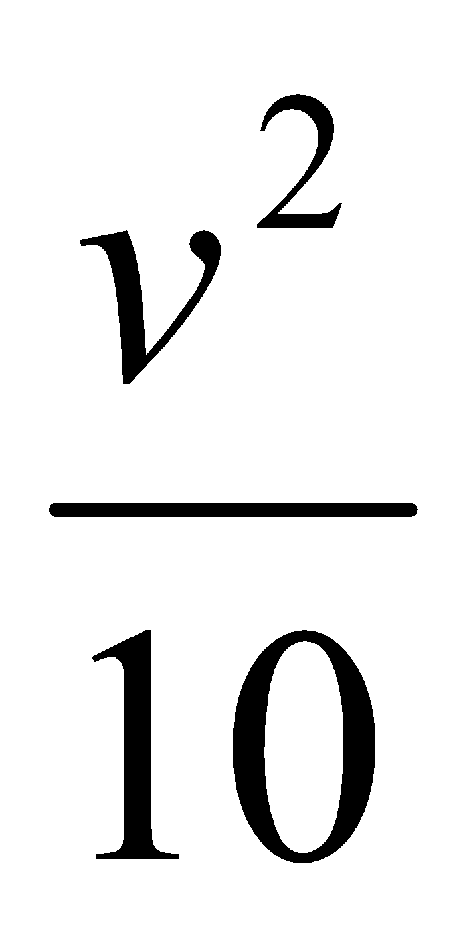, where v is the velocity. The initial velocity is 5 m/s.
In how many seconds will the velocity of the body be 2 m/s and how far will it travel in that time?

1997 (b)
A particle moves in a straight line and undergoes a retardation of 0.04v³ m/s², where v is its speed.
- If the initial speed of the particle is 25m/s, find its speed when it has travelled a distance of 49 m.
- Find the time for the speed to reduce from 25m/s to 15m/s.

2002 (b)
A particle starts from rest and moves in a horizontal line.
Its speed v at time t is given by the equation 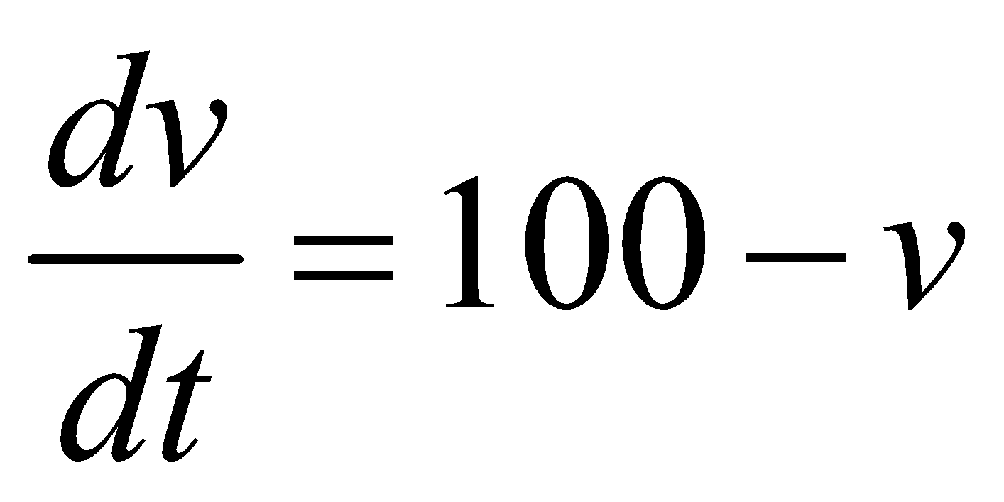.
- Find the time taken for the speed of the particle to increase from 25 m/s to 75 m/s.

- How far does the particle travel in going from rest to a speed of 75 m/s?
- Determine the limiting speed, v₁ of the particle (that is v → v₁ as t → ∞ ).

1980 (b)
A car starts from rest.
When it is at a distance s from its starting point, its speed is v and its acceleration is 5 – v².
Show that vdv = (5 – v²) ds and find as accurately as the tables allow its speed when s = 1.5.

2010 (b) {arithmetic is unwieldy}
The acceleration of a cyclist freewheeling down a slight hill is 0.12 – 0.0006v² m s⁻² where the velocity v is in metres per second.
The cyclist starts from rest at the top of the hill.
Find
- the speed of the cyclist after travelling 120 m down the hill
- the time taken by the cyclist to travel the 120 m if his average speed is 2.65 m s⁻¹.

2000 (b)
The deceleration of a particle moving in a straight line with speed v m/s has magnitude 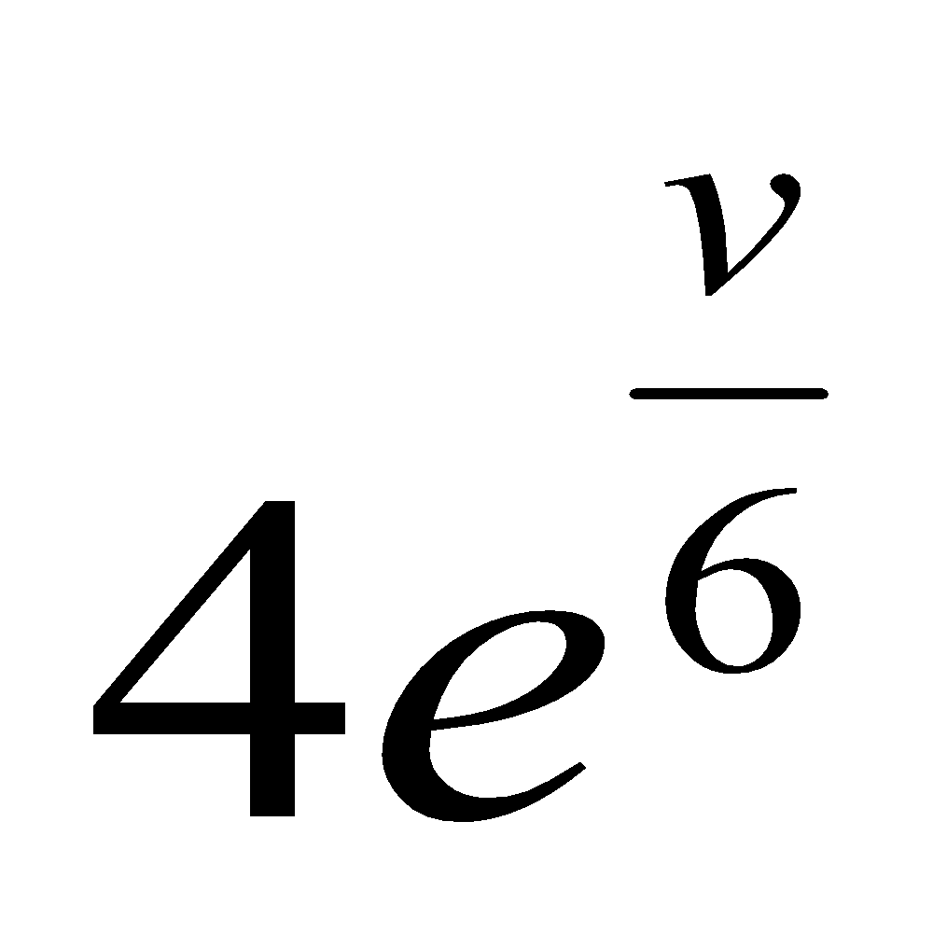 m/s².
The particle has an initial speed of 6 m/s.
- Find the time t₁ for the speed to decrease to 3 m/s.
- Find the time t₂ for the particle to come to rest.
- Deduce that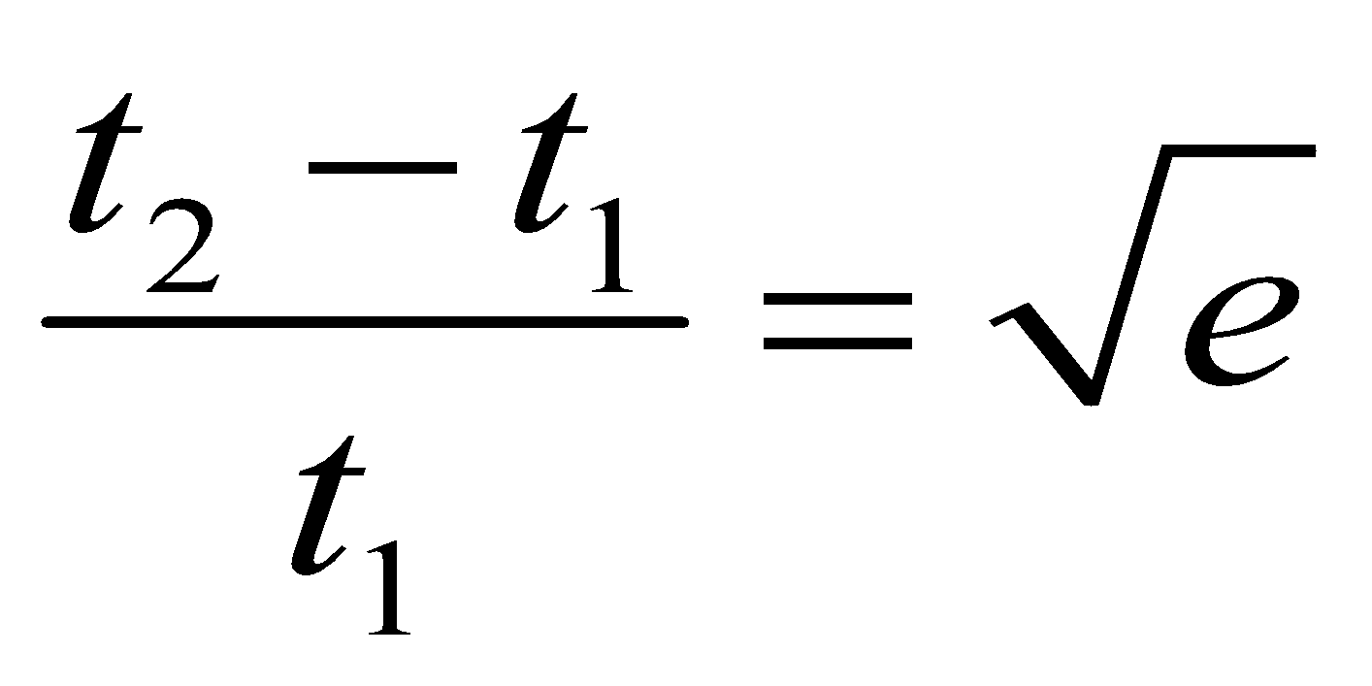.

2007 (b)
The acceleration of a racing car at a speed of v m/s is $\left(1-\frac{v^{2}}{3200}\right)$ m s⁻².
The car starts from rest.
Calculate correct to two decimal places
- the speed of the car when it has travelled 1500 m from rest
- the maximum speed of the car.

2017 (a) {last part tricky}
A particle starts from rest and moves in a straight line with acceleration (25 – 10v) m s^{–2}, where v is the speed of the particle.
- After time t, find v in terms of t.

- Find the time taken to acquire a speed of 2∙25 m s^{–1} and find the distance travelled in this time.

2011 (b) {difficult}
A particle travelling in a straight line has a deceleration of $\frac{v^{2}}{400}+16$ m s⁻² where v is its speed at any time t.

If its initial speed is 40 m s⁻¹, find
- the distance travelled before it comes to rest
- the average speed of the particle during the motion.

Linking displacement and time
To do this you must first use either $a=\frac{dv}{dt}$ or $a=v\frac{dv}{ds}$ (to link v & t or v & s)

Then substitute $\frac{ds}{dt}$ for v and continue
1998 (b)
A particle moves in a straight line. The initial speed is u and the retardation is kv³, where v is the speed at the time t. If s is the distance travelled in time t, prove
- 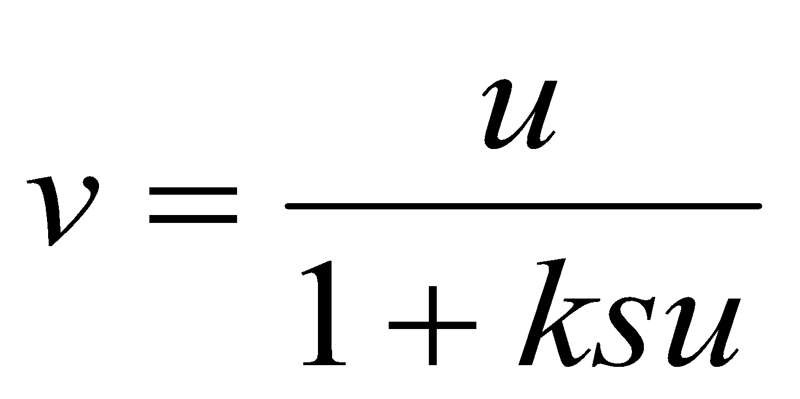

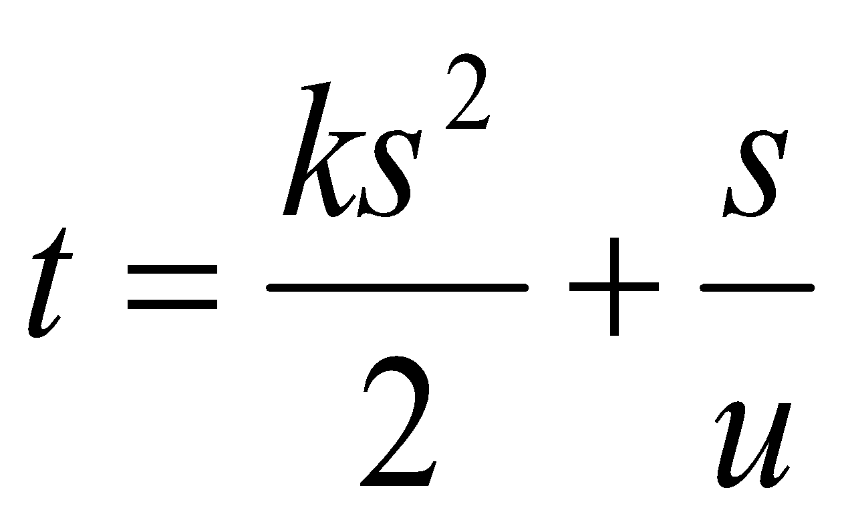

1982 (b)
A particle moves in a straight line with acceleration equal to minus the square of its velocity.
If its initial velocity is 1 m/s, calculate the distance travelled one second later.

1981 (b)
A particle moves in a straight line so that at any instant its acceleration is, in magnitude, half its velocity. If its initial velocity is 3 m/s, find an expression for the distance it describes in the fifth second.

2022 Deferred (b)
A particle is projected horizontally along a smooth horizontal surface with initial speed 80 m s⁻¹.
The particle has a retardation of $\frac{v}{100}$ m s−², where 𝑣 is the speed.
Find
(i) the speed of the particle after t seconds
(ii) the distance travelled in t seconds
(iii) the speed 𝑣 in terms of the distance travelled, s.

2022 (a)
A particle moves in a horizontal line such that its speed 𝑣 at time 𝑡 is given by the differential equation
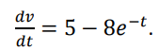

- Given that 𝑣 = 2 when t = 0, find an expression for 𝑣 in terms of 𝑡.
- Find the minimum value of 𝑣.
- Find the distance travelled by the particle before it attains its minimum speed.

2020 Question 10 (b)
A particle P travelling in a straight line has a deceleration of 4v^{n+1} m s^{–2}, where n (> 0) is a constant and v is its speed at time t (> 0).

P has an initial speed of u.
- Find an expression for v in terms of u, n and t.
- When n = 3 obtain an expression for the speed of P when it has travelled a distance of 3 m from its initial position.

2019 (a)
A particle P moves along a straight line.
The speed of P at time 𝑡 is 𝑣, where 𝑣=𝑎𝑡² +𝑏𝑡+𝑐 and 𝑎,𝑏 and 𝑐 are constants.
The initial speed of the particle is 15 m s⁻¹.
After 2∙5 seconds the particle reaches its minimum speed of 2∙5 m s⁻¹.
Find
- the value of 𝑎, the value of 𝑏, and the value of 𝑐
- the acceleration of P when 𝑡 = 4 seconds
- the distance travelled by P in the third second of the motion.

2016 (a)
At time t seconds the acceleration a m s^{–2} of a particle, P, is given by a = 8t + 4.
At t = 0, P passes through a fixed point with velocity −24 m s^{–1}.
- Show that P changes its direction of motion only once in the subsequent motion.
- Find the distance travelled by P between t = 0 and t = 3.

2016 (b)
A particle moves along a straight line in such a way that its acceleration is always directed towards a fixed point O on the line, and is proportional to its displacement from that point.
The displacement of the particle from O at time t is x.

The equation of motion is $v\frac{dv}{ds}=-ω^{2}$x

where v is the velocity of the particle at time t and ω is a constant.
The particle starts from rest at a point P, a distance A from O.
Derive an expression for
- v in terms of A, ω and x
- x in terms of A, ω and t.

2015 (a)
Two cars, A and B, start from rest at O and begin to travel in the same direction.
The speeds of the cars are given by v_{A} = t² and v_{B} = 6t ‒ 0.5t², where v_{A} and v_{B} are measured in m s^{–1} and t is the time in seconds measured from the instant when the cars started moving.
- Find the speed of each car after 4 seconds.
- Find the distance between the cars after 4 seconds.
- On the same speed-time graph, sketch the speed of A and the speed of B for the first 4 seconds and shade in the area that represents the distance between the cars after 4 seconds.

2014 (b)
A particle moves in a straight line with an acceleration of (2t – 3) m s^{–2} at time t seconds.
At time t = 0 the particle has velocity of 2 m s^{–1} and displacement of 1 m relative to a fixed point O on the line.
Find
- the times when the particle changes direction
- an expression for the displacement of the particle from O at time t
- the total distance travelled in the first 2 seconds.

2014 (a)
A particle moving in a straight line experiences a retardation of 0.7v³ m s^{–2}, where v m s^{–1} is its speed.
It takes 0.04 seconds to reduce its speed from an initial value of 200 m s^{–1} to v₁ m s^{–1}.
Find
- the value of v₁
- the distance travelled during this 0.04 seconds.

2013 (b)
A particle starts from rest at O at time t = 0. It travels along a straight line with acceleration (24t −16) m s⁻², where t is the time measured from the instant when the particle is at O.
Find
- its velocity and its distance from O at time t = 3
- the value of t when the speed of the particle is 80 m s⁻¹.

2006 (b)
The acceleration of a particle moving horizontally in a straight line is $\frac{1}{x^{3}}$away from a fixed point o, where x is its distance from o. The particle starts from rest at x = 1.
- Calculate the velocity of the particle when$x=\frac{4}{3}$.
- Calculate the time that it takes the particle to reach a point 2 metres from o.

Motion expressed in terms of forces

***********************************************************************************
Either all terms must represent an acceleration or a force, but you cannot mix them.

If the right hand side is expressed as a (net) force then the term on the left hand side must be expressed as a force (e.g. mdv/dt).
Sometimes it’s not obvious whether a term in the question is an acceleration or a force; look at the units to help you.

If the resistance is expressed as kv² N per unit mass then mathematically the resistive force = - mkv² (it is a force).

***********************************************************************************

ALWAYS REMEMBER: IF IT MOVES, INTEGRATE IT!!

***********************************************************************************

1986 (b)
A particle moves in a straight line in a medium whose resistance is proportional to the cube of its speed.
No other force acts on the body.
The speed falls from 15 m/s to 7.5 m/s in a time of t seconds. Show that the distance travelled in this time is 10t m.

1991 (b)
A particle is projected in a straight line from a fixed point with velocity u at time t = 0. It is opposed by a resistance kv^{n} per unit mass. If s is the displacement at time t prove that 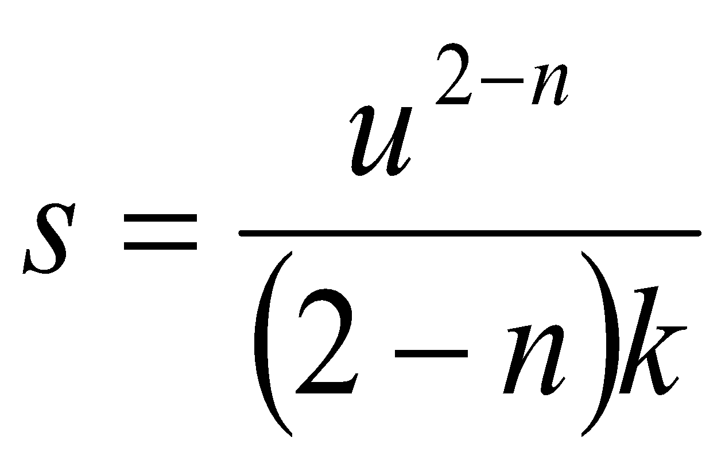when v = 0 is n < 1.

1988 (b)
A particle of mass m is projected vertically upwards with speed 120 m/s in a medium where there is a resistance of 0.098v² per unit mass of the particle when v is the speed.
Calculate the time taken to reach the highest point.

1983 (b)
A particle of mass 8 kg moves along a line (the x-axis) on a smooth horizontal plane under the action of a force in newtons of (40 – 3$\sqrt{x}$) i where i is the unit vector along the axis and x is the displacement of the particle from a fixed point o of the axis.
If the particle starts from rest at o, find its speed when x = 100 and calculate when it next comes to instantaneous rest.

1974
A particle of mass 0·1 kg falls vertically from rest under gravity in a medium which exerts a resisting force of magnitude 0·02v newtons when the speed of the particle is v m/s.
- Show that v = 49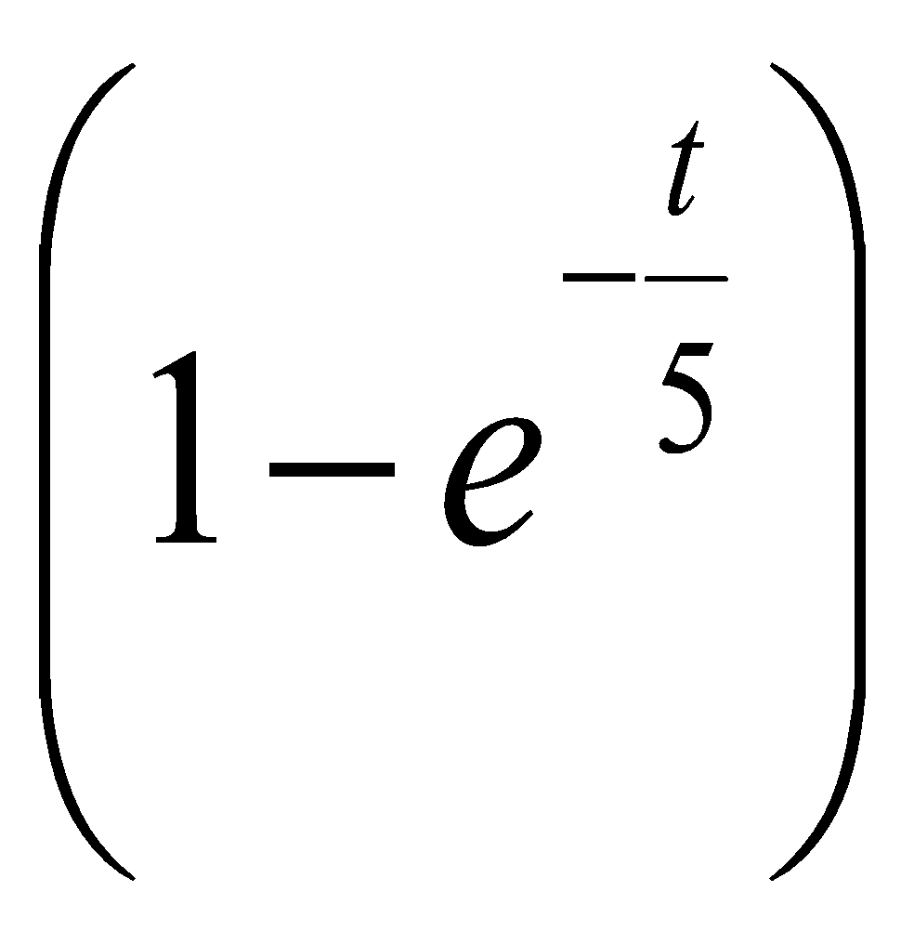 and find ${\left(v\right)}^{}$

- Find an expression for the distance travelled in time t seconds.

1976 {straightforward approach, algebra is a bit cumbersome}
An atomic nucleus of mass M is repelled from a fixed point o by a force M k²x⁻⁵, where x is the distance of the nucleus from o and k is a constant.
It is projected directly towards o with speed 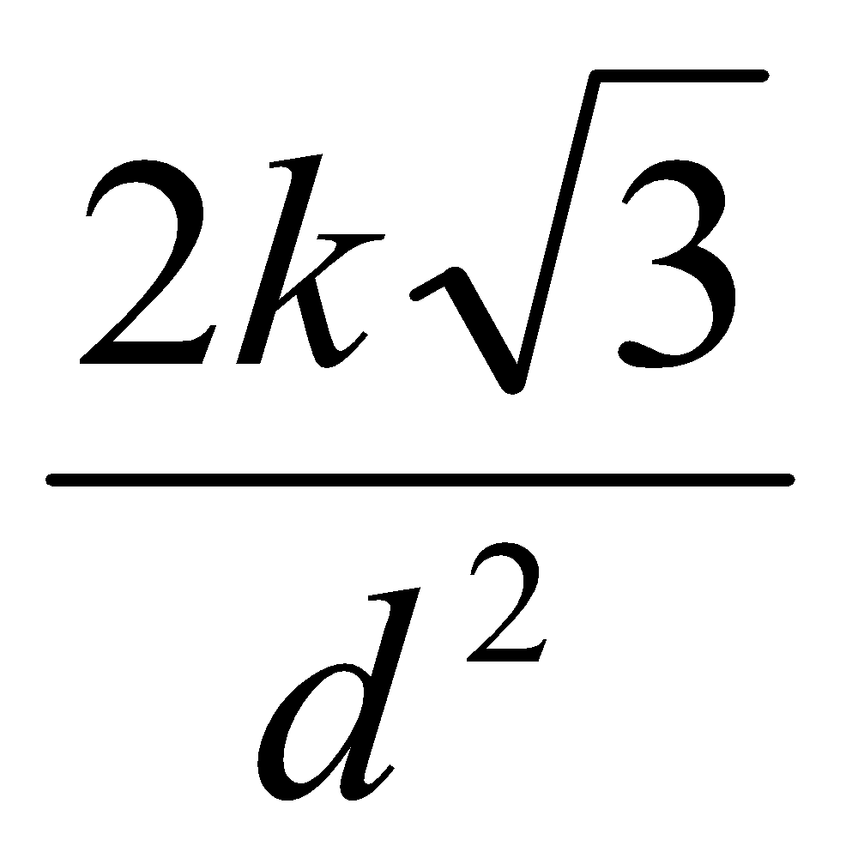 from a point a where |oa| = d.
Find the speed of the nucleus when if reaches the midpoint of oa and find how near it gets to o.

2012 (b)
A particle of mass m is fired horizontally through a block of resistive gel.
The resistance to motion is mkv² N when v m s^{–1} is the speed.
The particle enters the gel at a speed of 1000 m s^{–1} and $\frac{1}{100}$ seconds later exits the gel at a speed of 10 m s^{–1}.
- Show that k = $\frac{99}{10}$
- Show that the length of the block of gel is $\frac{10}{99}$ ln100 m.

1985 (b)
A particle of mass m moves in a straight line.
The only force acting on it being a resistance mkv², where v is its speed and k is a constant.
It is initially projected from the point o with speed u.
When the particle reaches a point p on the line its speed is u/3.
- Show that the average speed between o and p is ½ uln3.
- Find the speed of the particle when it is at the midpoint of [op].

1995 (b) {Part (ii) is tricky (but at least it’s short)}
A particle of mass m falls from rest against air resistance of mkv, where k is constant and v is the speed. Prove that
- the time taken to acquire a speed of 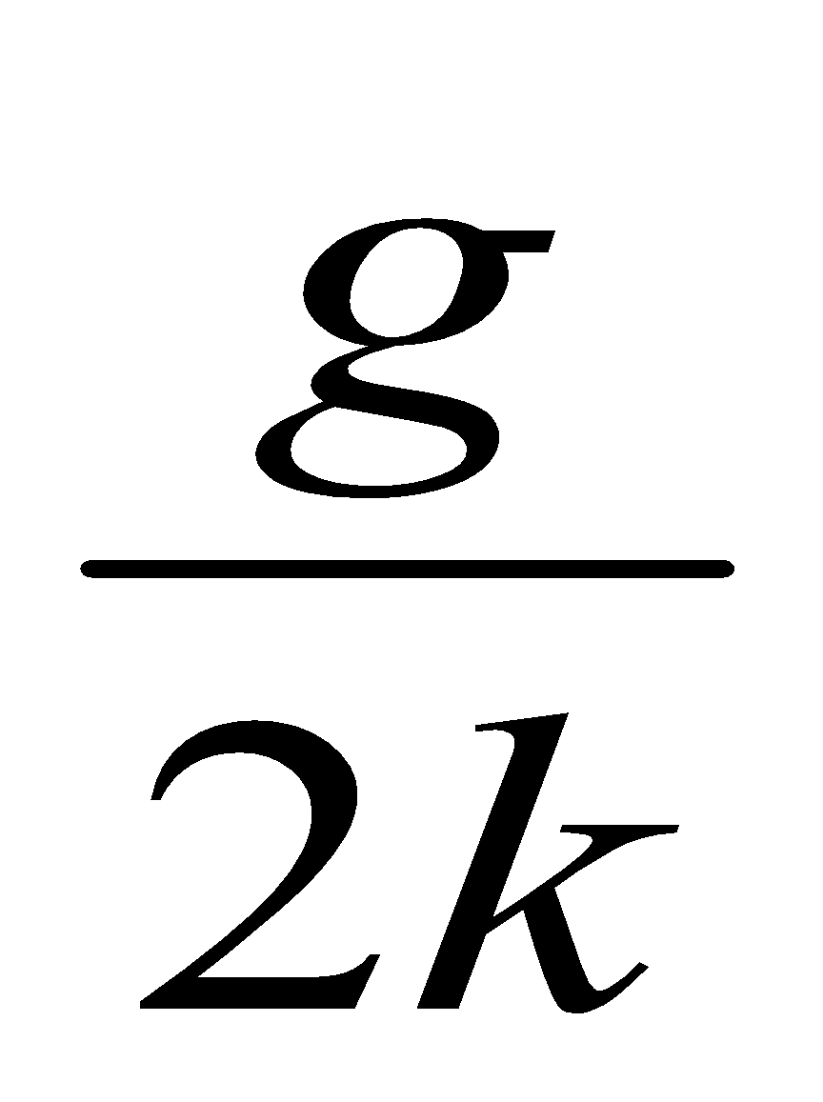 is 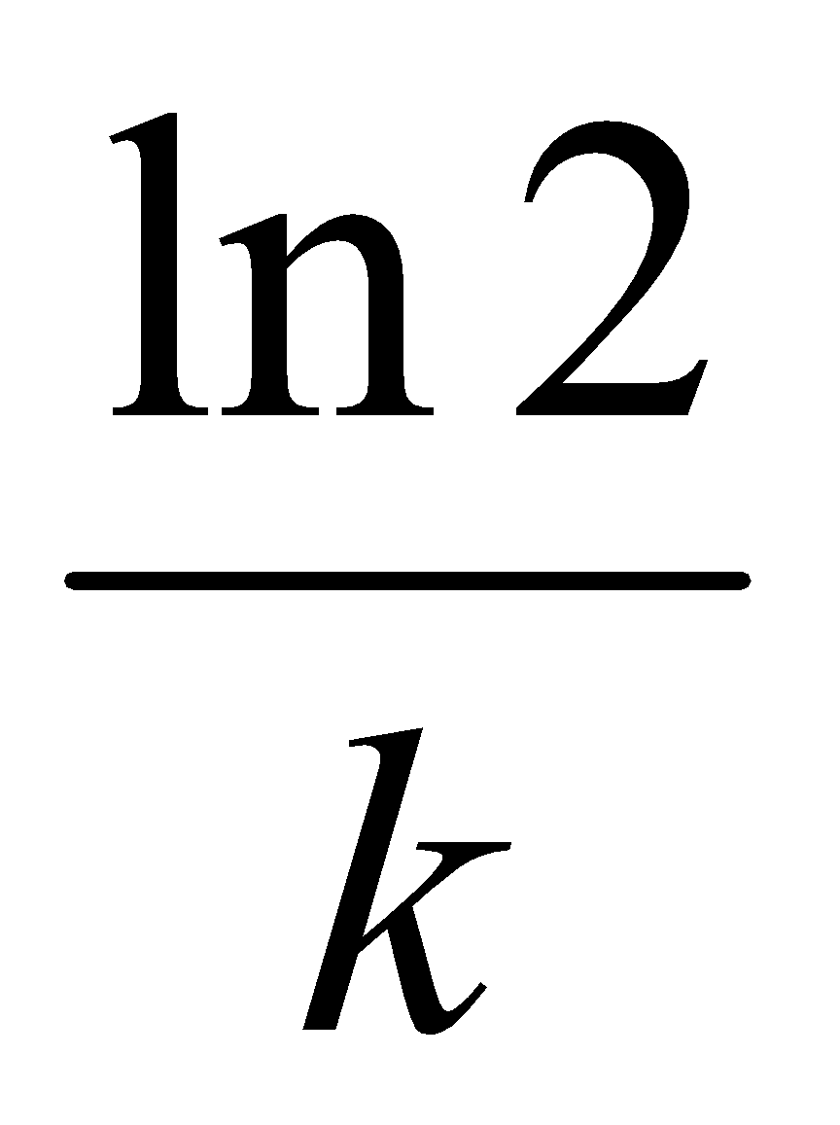
- the speed of the particle tends to a limit 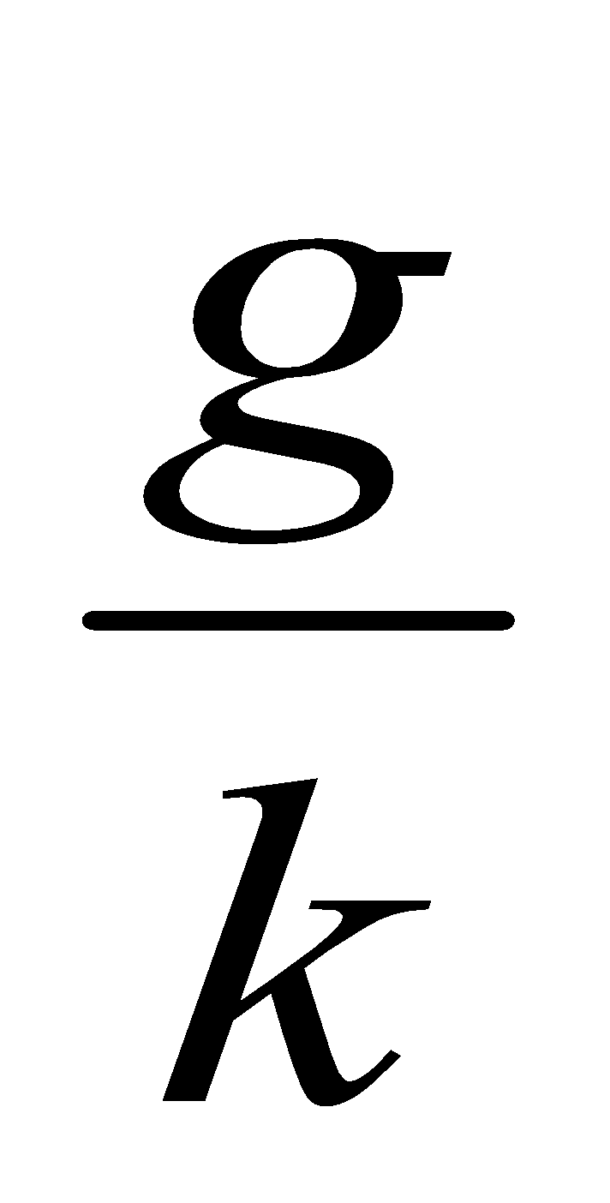

1978 (b)
A particle of mass m is acted on by a force $\frac{2m}{x^{5}}$ directed away from a fixed point O, where x is the distance of the particle from O.
The particle starts from rest at a distance d from O.
Show that the velocity of the particle tends to a limit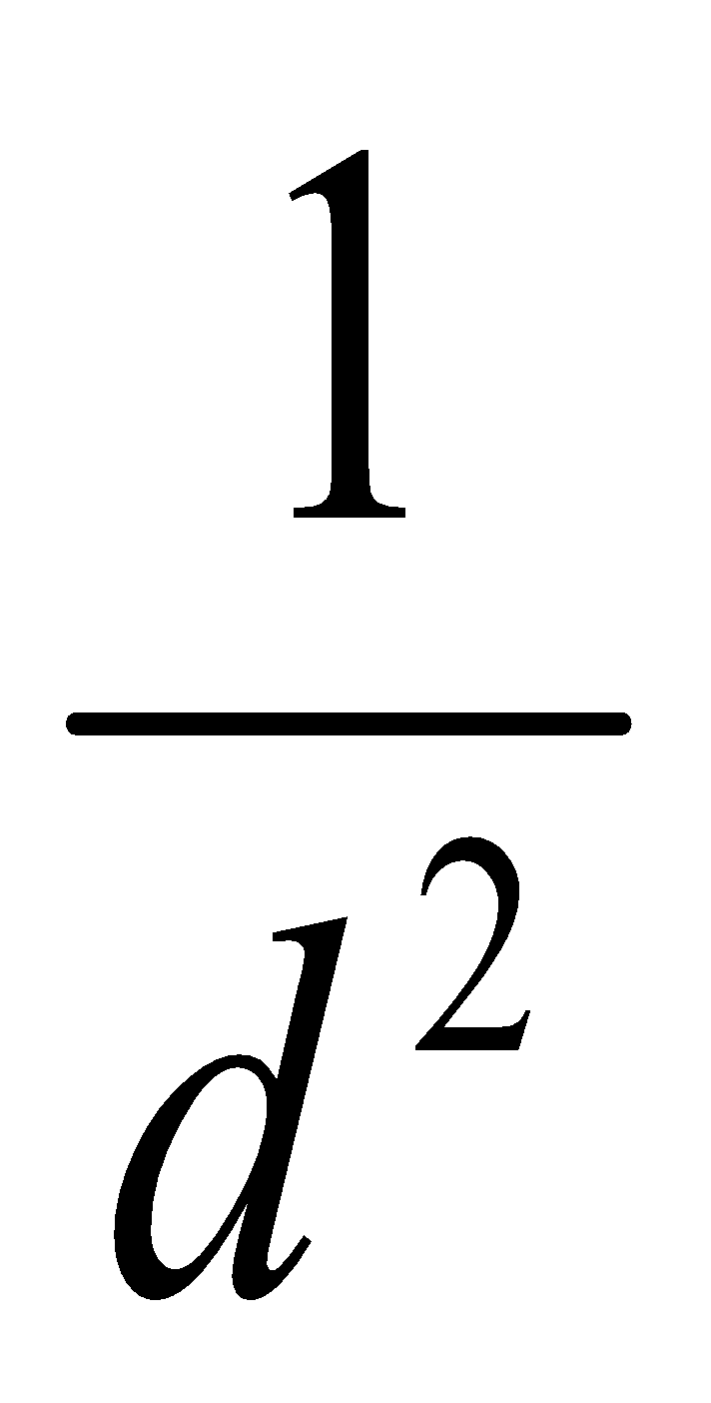.

2001 (b)
A car of mass m kg is travelling along a level road. The resistance to motion is mkv² N, where v m/s is the speed. When the car is travelling at 14 m/s, the engine cuts out.
Ten seconds after the engine cuts out, the speed of the car is 7 m/s.
- Show that k =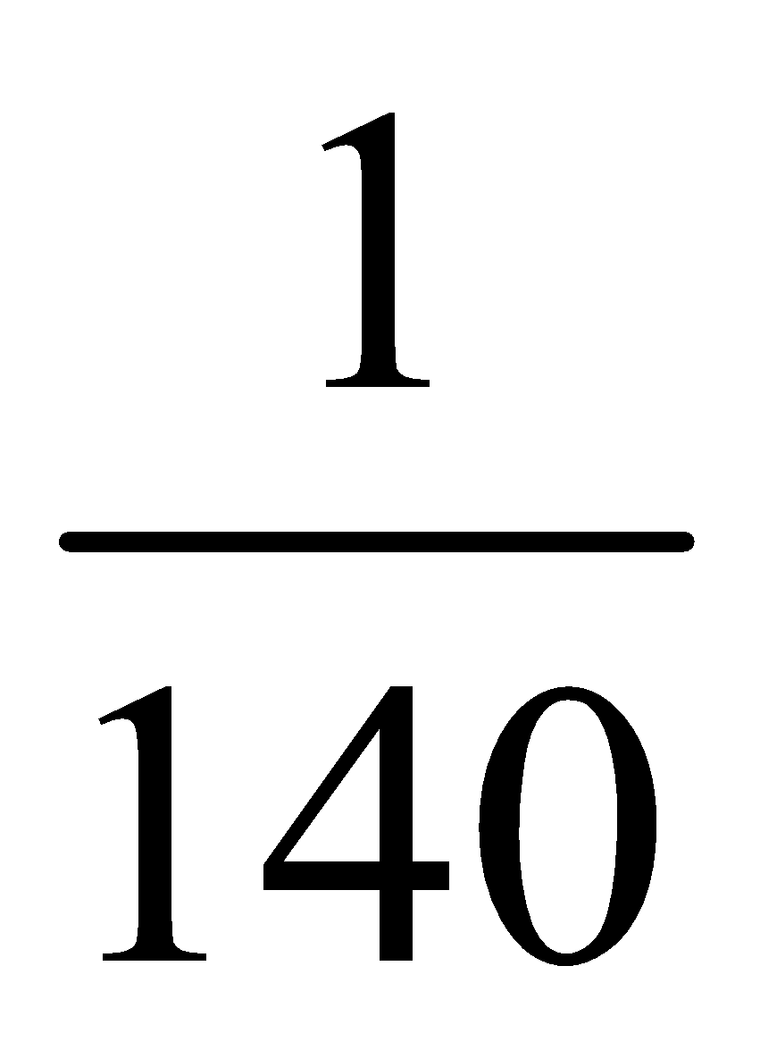.
- The car travels a distance of s metres in the first T seconds after the engine cuts out.
Show that 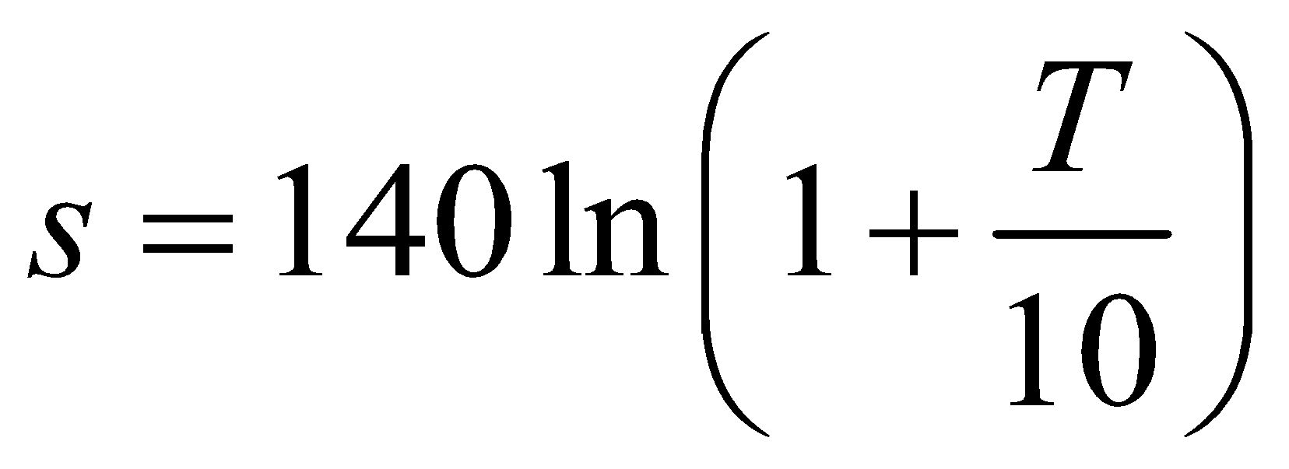

1993 (b)
A particle starts with a speed of 20 m/s and moves in a straight line.
The particle is subjected to a resistance which produces a retardation which is initially 8 m/s² and which increases uniformly with the distance moved, having a value of 9 m/s² when the particle has moved a distance 5 m.
If v m/s is the speed of the particle when it has moved a distance x m
- prove that, while the particle is in motion 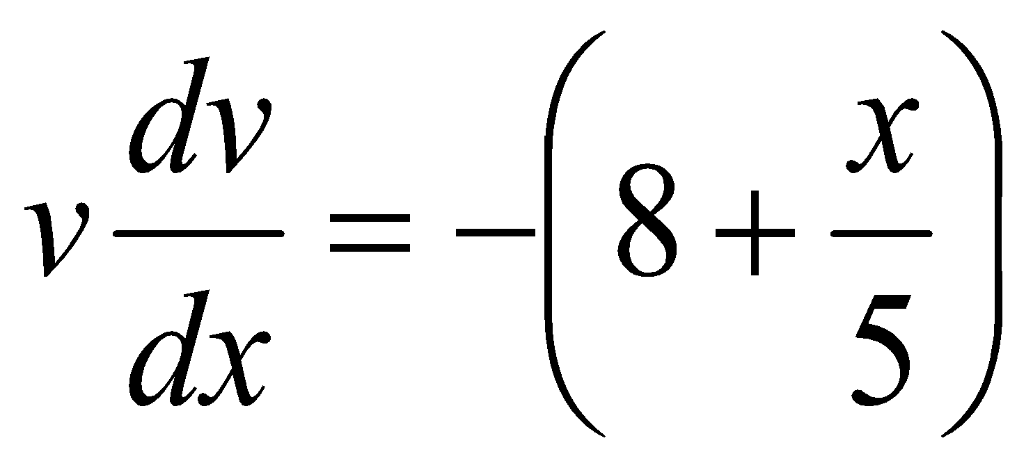
- Calculate the distance moved by the particle in coming to rest.

1990 (b)
A particle of mass 8 kg starts from rest and is acted on by a force which increases uniformly in 10 s from zero to 16 N.
- Prove that t seconds after the particle begins to move, its acceleration is m/s².
- Prove that, when the particle has moved x m, its speed is v m/s, where 10v³ = 9x².

2019 (b)
A particle, of mass 𝑚 falls vertically downwards under gravity.
At time 𝑡, the particle has speed 𝑣 and it experiences a resistance force of magnitude 𝑘𝑚𝑣, where 𝑘 is a constant.
The initial speed of the particle is 𝑢.
- Show that 𝑣 = $\frac{g}{k}-(\frac{g}{k}-u)e^{-kt}$, at time 𝑡.
- If 𝑢=9∙8 m s⁻¹ and 𝑘=0∙98 s⁻¹, find the distance travelled by the particle in 4 seconds.

2017 (b) {difficult}
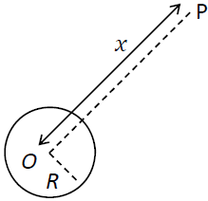
A spacecraft P of mass m moves in a straight line towards O, the centre of the earth.
The radius of the earth is R.
When P is a distance x from O, the force exerted by the earth on P is directed towards O and has magnitude $\frac{k}{x^{2}}$, where k is a constant.

- Show that k = mgR².
- P starts from rest when its distance from O is 5R.
Find, in terms of R, the speed of P as it hits the surface of the earth, given that air resistance can be ignored.

1975
The force of attraction of the earth on a particle of mass M distance x from the centre of the earth is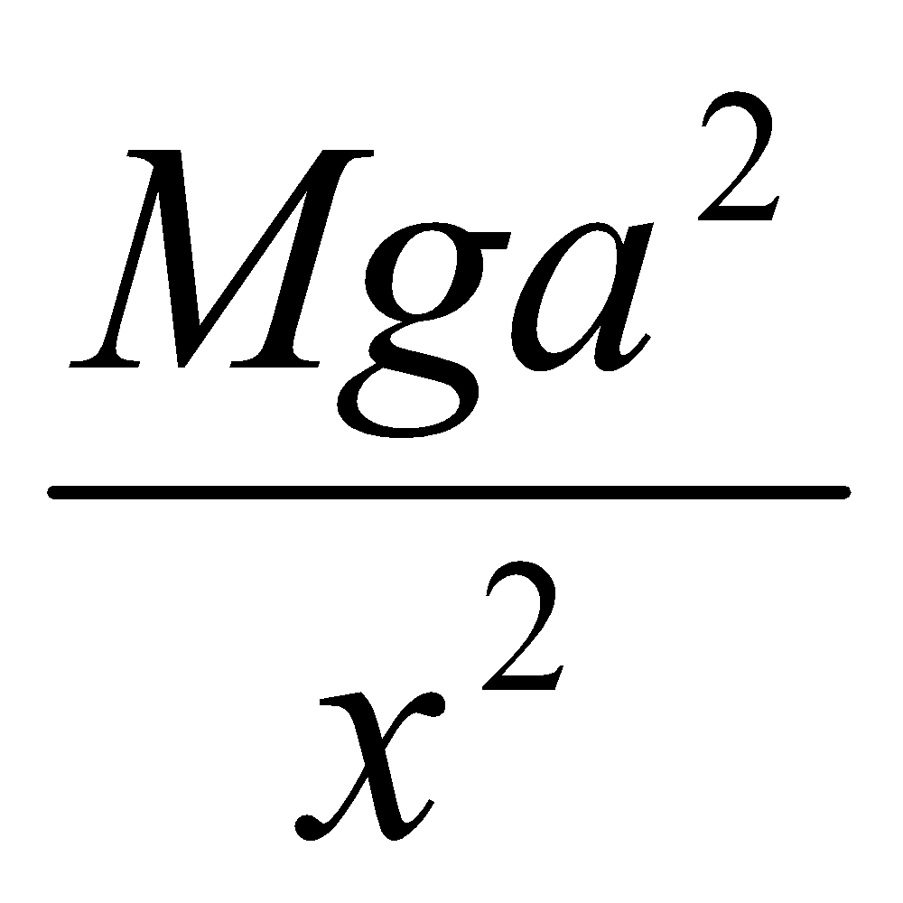, where a is the radius of the earth 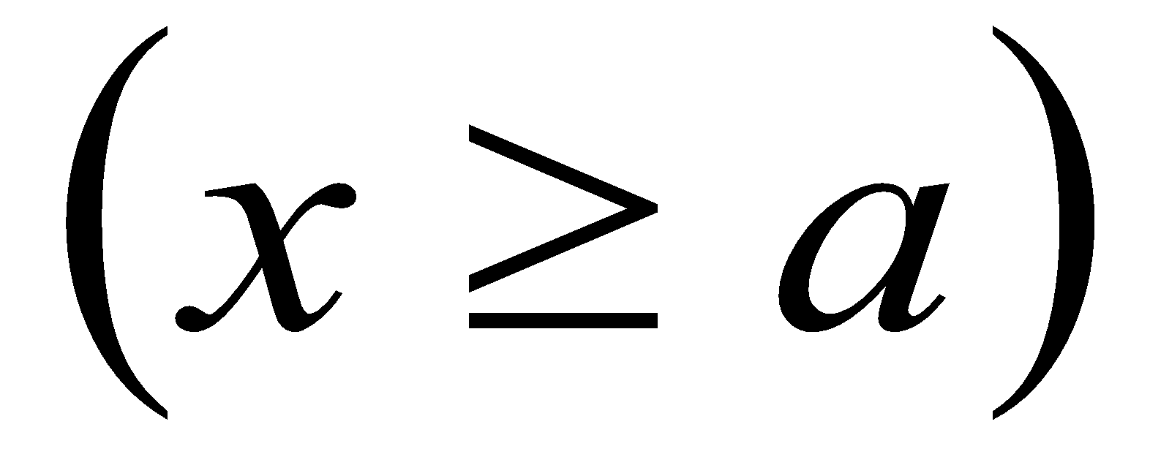.
Write down the equation of motion for a particle moving under this force alone and calculate the speed of the particle at distance x if it was projected vertically upwards from the earth’s surface with speed 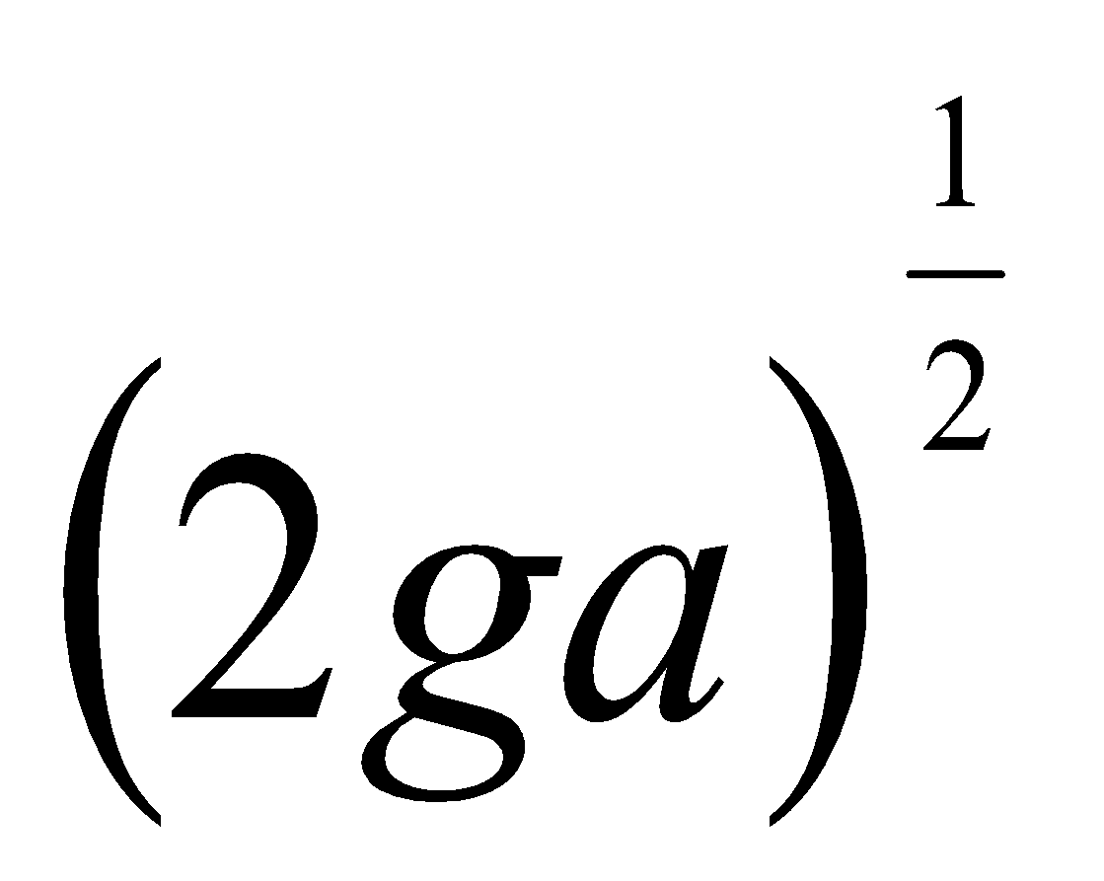.
Prove that the time taken to reach a height 3a above the earth’s surface is 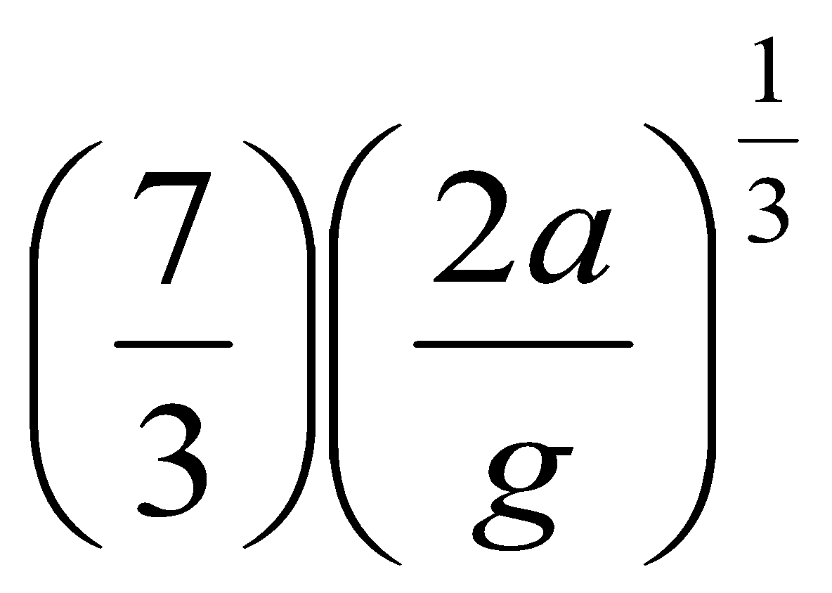.

Work done by a variable force

Note: for part (iii) you can’t use W = F.s because the force is not constant.
You can’t use PE + KE = constant because there is an external force in this context.
You have to use what is known as The Work-Energy theorem which states that the total work done is equal to its change in kinetic energy.

2005 (b)
A mass of 9 kg is suspended at the lower end of a light vertical rope.
Initially the mass is at rest. The mass is pulled up vertically with an initial pull on the rope of 137.2 N.
The pull diminishes uniformly at the rate of 1 N for each metre through which the mass is raised.
- Show that the resultant upward force on the mass when it is x metres above its initial position is 49 − x.
- Find the speed of the mass when it has been raised 15 metres.
- Find the work done by the pull on the rope when the mass has been raised by 15 m.

Power, force and velocity
Work = Force × displacement
W = F.s (now divide both sides by t)
P = F.v

2021 (a)
A car of mass 1200 kg starts from rest and travels along a straight horizontal road.
The engine of the car exerts a constant power of 3000 W.
If there is no resistance to the motion of the car, find
- the speed of the car after 3 minutes
- the average speed of the car during this time.

1994 (b)
A car of mass 1000 kg moves with velocity v m s⁻¹ along a horizontal road against a constant resistance of 1500 N.
The engine is working at a constant rate of 75 kW.
- Show that the acceleration of the car is 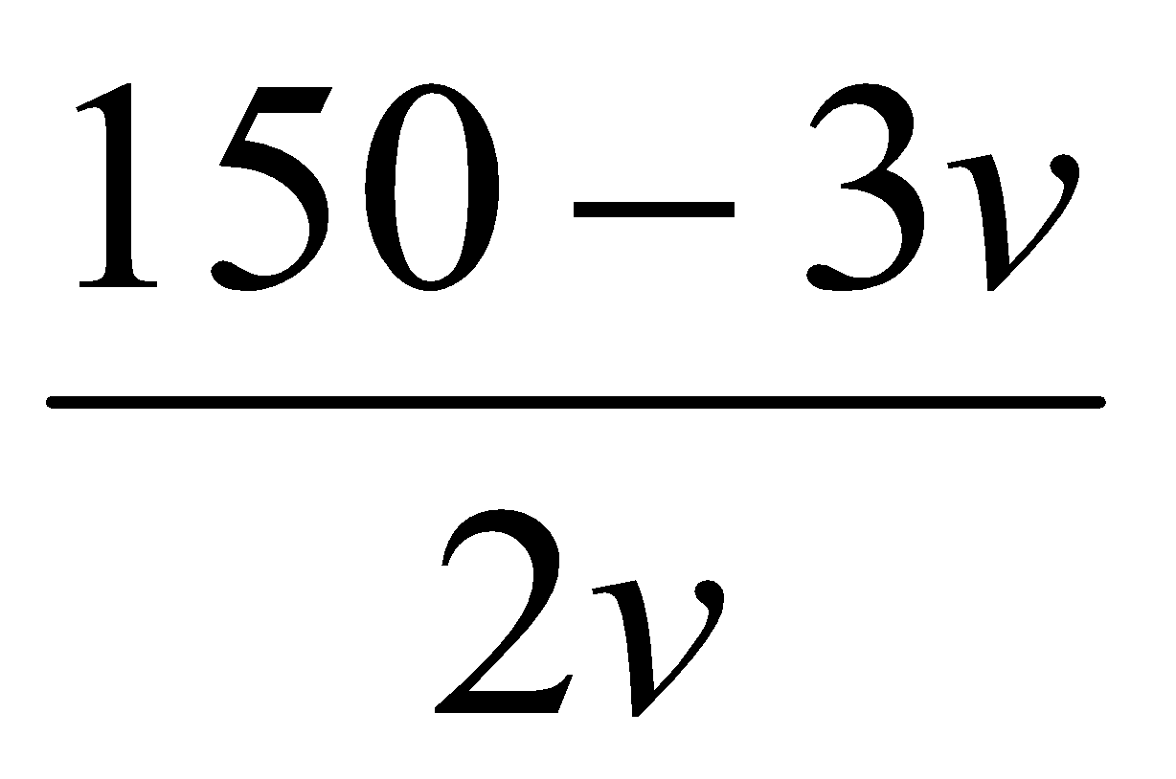 m s⁻².
- Calculate, correct to two decimal places, the time taken by the car to increase its speed from 0 m s⁻¹ to 25 m s⁻¹.

2003 (b)
A car of mass 490 kg moves along a straight level horizontal road against a resistance of 70v N, where v m/s is the speed of the car. The engine exerts a constant power of 63 kW.
- Show that the equation of motion is 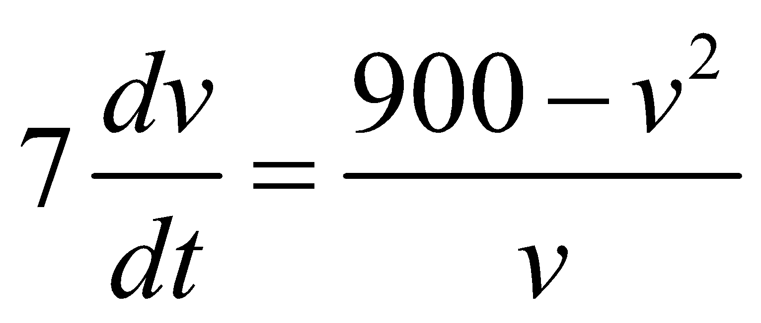.
- Calculate, correct to two decimal places, the time it takes the car to increase its speed from 10 m s⁻¹ to 20 m s⁻¹.

2008 (b) {a little trickier than the previous question - 2003 (b)}
A train of mass 200 tonnes moves along a straight level track against a resistance of 400v², where v m s⁻¹ is the speed of the train.
The engine exerts a constant power of P kW.
The acceleration of the train is 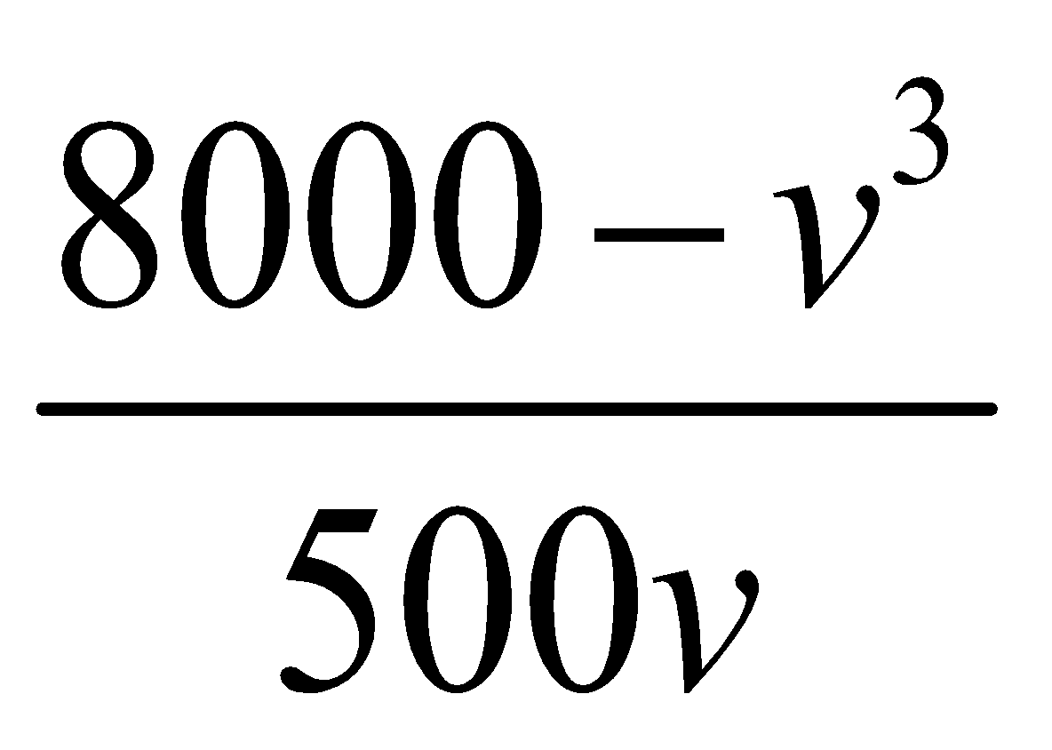.
- Find the value of P.
- The train travels a distance 69.07 m while its speed increases from 10 m s⁻¹ to v₁ m s⁻¹.
Find the value of v₁.

1987 (b) {very tricky}
The resistance to motion of a train of mass m is constant and equal to 60 N per tonne.
When moving with constant speed 16 m/s on a level line the train begins to ascend an incline of 1 in 98, i.e. sin⁻¹(¹/₉₈).
- Assuming that the engine continues to work at the same rate (ie power is constant) and that v m/s is the speed of the train up the incline t seconds after the train has begun to climb, show the equation of motion is 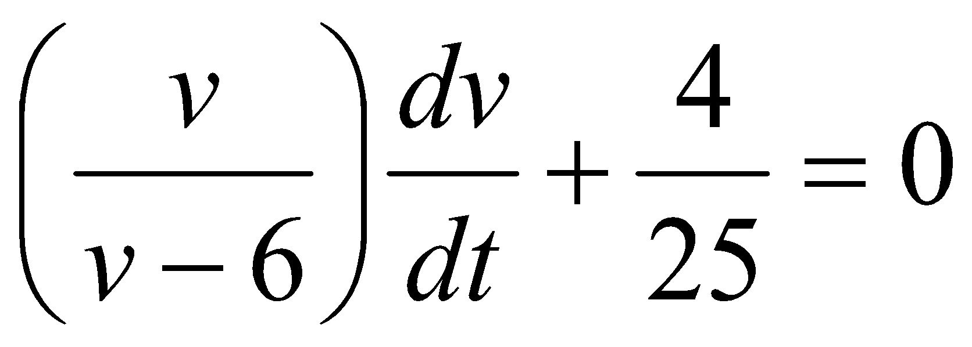
- Calculate the time which elapses before the velocity falls to 12 m/s.

Difficult/very difficult questions
1999 (b) {difficult}
The rocket engine of a 12 tonne missile produces a thrust of 180.1 kN.
The missile is launched in a vertical direction. The air resistance is v² N where v is the speed of the missile.
- Find the speed of the missile after 30 seconds.
- Find the percentage error in this speed if air resistance is ignored.

1996 (b) {difficult}
A particle of mass m is projected vertically upwards with a velocity v of 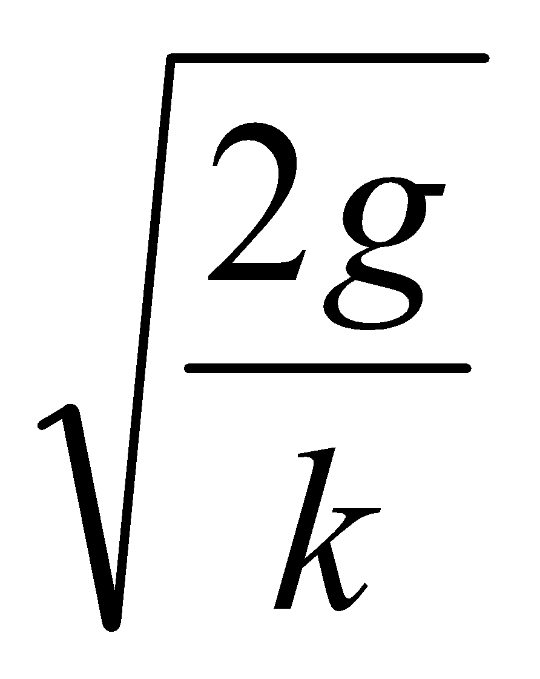, the air resistance being kv² per unit mass. Prove
- the greatest height reached by the particle is 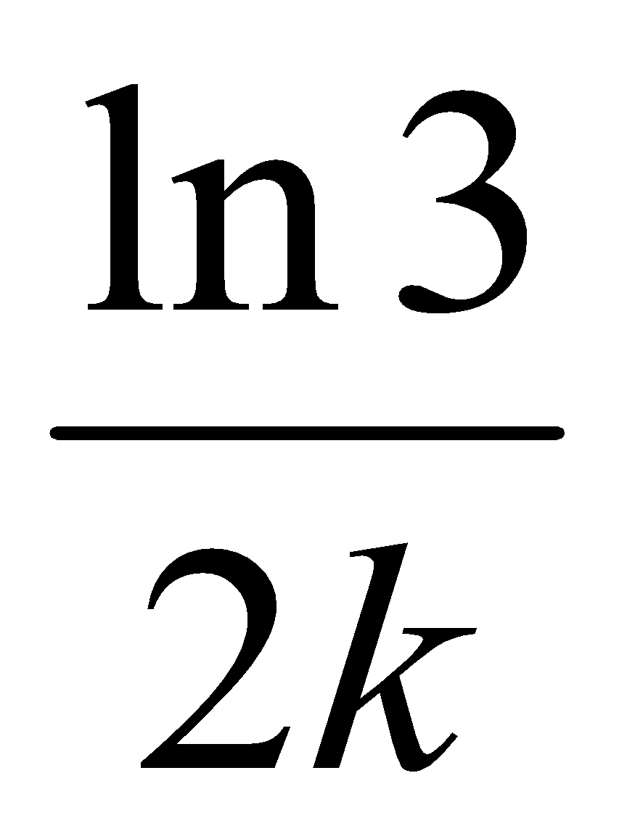
- the velocity of the particle when passing through the point of projection on the way down is 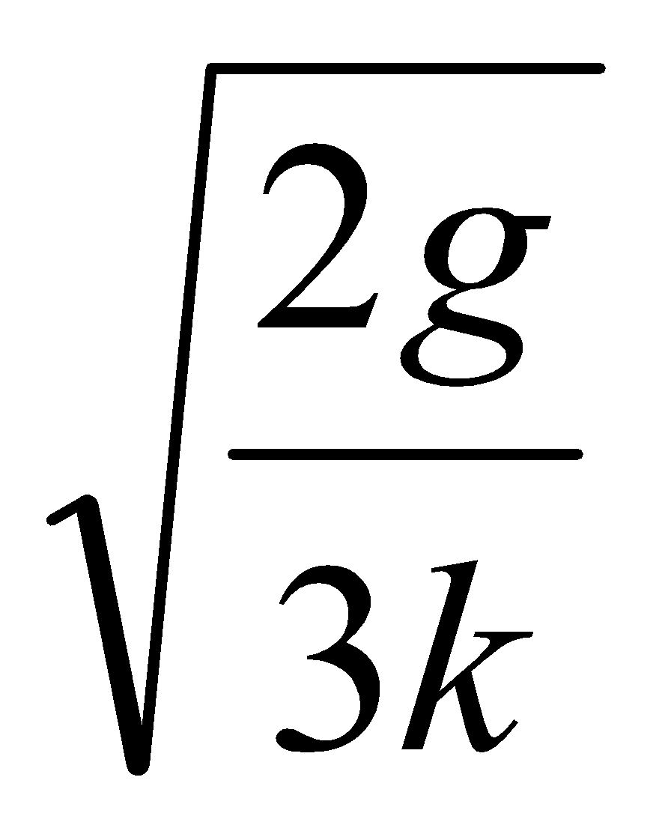

2009 (b) {integration for part (ii) is ridiculous}
A particle of mass m is projected vertically upwards with speed u. The air resistance is kv² per unit mass when the speed is v.
The maximum height reached by the particle is ln (4/(2k)).
- Find the value of u in terms of k.

- Find the value of k if the time to reach the greatest height is π/3 seconds.

2004 (b) {Part (ii) is ridiculous}
A particle is projected vertically upwards with an initial speed of 2g m/s in a medium in which there is a resistance kv² N per unit mass where v is the speed of the particle and k is a constant, where k > 0.
- Prove that the maximum height reached is 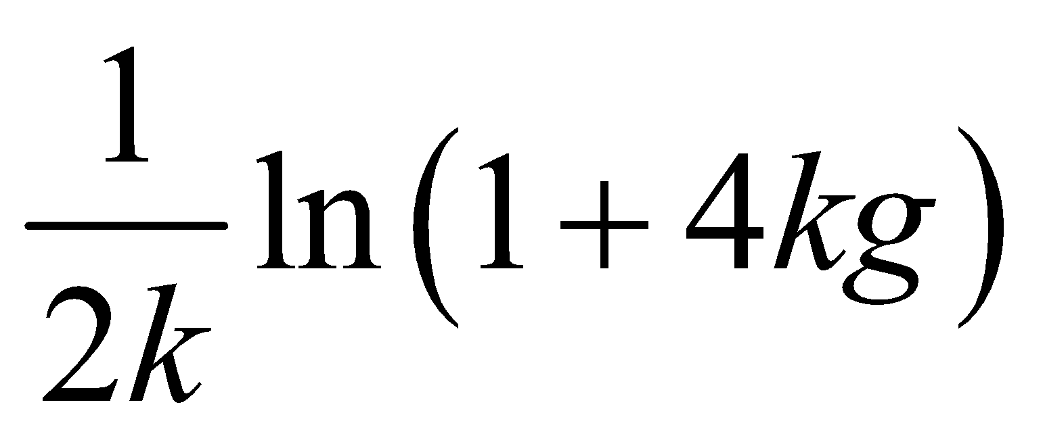
- If the speed of the particle is g m/s when it has reached half its maximum height, find the value of k.

Applying differential equations to non-mechanics questions

There has been a distinct shift in emphasis in the Differential Equations questions in recent years. Whereas in the past the questions dealt exclusively with mechanics (velocity and acceleration), they have now started to include other applications, like financial maths and population growth.
Expect something similar vein this year.
***********************************************************************************

GENERAL RULE OF THUMB: IF IT CHANGES, INTEGRATE IT!!

2018 (b)
If there were no emigration, the population x of a certain county would increase at a constant rate of 2·5% per annum. By emigration the county loses population at a constant rate of n people per annum.
When the time is measured in years then $\frac{dx}{dt}=\frac{x}{40}-n$
- If initially the population is P people, find in terms of n, P and t, the population after t years.
- Given that n = 800 and P = 30 000, find the value of t when the population is 29 734.

2013 (c)
Water flows from a tank at a rate proportional to the volume of water remaining in the tank.
The tank is initially full and after one hour it is half full.
After how many more minutes will it be one-fifth full?

2012 (a)
Newton’s law of cooling states that ‘the rate of cooling of a body is proportional to the difference between the temperature of a body and the temperature of its surroundings.’
If θ is the difference between the temperature of a body and the temperature of its surroundings then
$$\frac{dθ}{dt}= -kθ$$
A body cools from 80° C to 60° C in 10 minutes.
The temperature of the surroundings is maintained at 20° C.
Find
- the value of k
- the temperature of the body after a further 15 minutes.

2015 (b)
A company uses a cost function C(x) to estimate the cost of producing x items.
The cost function is given by the equation C(x) = F + V(x) where F is the estimate of all fixed costs and V(x) is the estimate of the variable costs (energy, materials, etc.) of producing x items.

$\frac{dC}{dx}$ = M(x) is the marginal cost, the cost of producing one more item.
A certain company has a marginal cost function given by M(x) = 74 +1.1x + 0.03x².
- Find the cost function, C(x).
- Find the increase in cost if the company decides to produce 160 items instead of 120.
- If C(10) = 3500, find the fixed costs.

2020 (a)
One method of dyeing a piece of cloth is to immerse it in a container which has P grams of dye dissolved in a fixed volume of water.
The cloth absorbs the dye at a rate proportional to the mass of dye remaining.
$$\frac{dx}{dt}=k(P-x)$$
where t is time in seconds, x is the mass of dye absorbed by the cloth and k = $\frac{1}{50}$.

- Find the time taken to dye a piece of cloth if a mass of $\frac{5}{8}$ 𝑃 needs to be absorbed to reach the desired colour.
(Note: $\int{}\frac{dx}{a+bx}= \frac{1}{b}ln\left|a+ bx\right|+ c$)

- An alternative method is to keep the mass of dye present in the water constant at P grams by continuously adding dye throughout the process.
Find the time taken to dye the piece of cloth to the desired colour using this method.

2021 (b)
𝑃, the population of insects in a region, grows at a rate that is proportional to the current population.
$$\frac{dP}{dt}= kP$$
where 𝑘 is a positive constant. In the absence of any outside factors the population will triple in 15 days.

- Find the value of 𝑘.

- A scientist begins to remove 10 insects from the population each day.
If there are initially 120 insects in the region the population will not survive.
After how many days will the population die out?

2022 (b)
The rate of decay at any instant of a radioactive substance is proportional to the amount of the substance remaining at that instant. The initial amount of the radioactive substance is 𝑁 and the amount remaining after time 𝑡 (hours) is 𝑥.
- Prove that 𝑥 = Ne^{-kt}, where 𝑘 is a constant.
- If the initial amount 𝑁 was reduced to $\frac{N}{3}$ in 14 hours, find the value of 𝑘.
- If the amount remaining is reduced from $\frac{N}{3}$ to $\frac{N}{4}$ in 𝑡 hours, find the value of 𝑡.

Guide to answering the exam questions
2011 (a)
- Straightforward once you figured out how to rearrange the terms to solve the integration.
Answer: distance = 44.63 m
- Straightforward. Answer: average speed = 19.24 m s⁻¹

2011 (b)

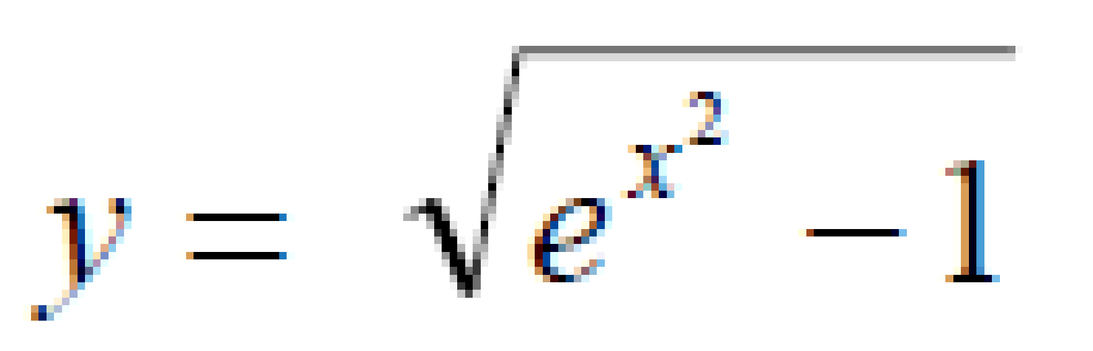
2010 (a)
Straightforward. Answer:

2010 (b)
- Straightforward to set up but the differentiation is difficult.
Answer: v = 5.18 m s⁻¹
- Straightforward. Answer: t = 45.3 s

2009 (a)
Straightforward. Answer: y = √(4x² – 1)

2009 (b)
- Care needs to be taken with the integration and algebra, but it’s nothing that hasn’t been seen before and is fairly straightforward. Answer: u = √(3g/k)
- This time you are given a time so you must go back to the start and use dv/dt. The integration this time is particularly nasty. Solve to get k = 1/g.

2008 (a)
Easy peasy. Ans: x = 1.

2008 (b)
- You need to know that Force = Power/velocity.
Ans: P = 3200 Watts
- Straightforward.
Ans: v = 15 m s⁻¹.

2007 (a)
Easy peasy. Ans: y = 1/(1+ Cos x)

2007 (b)
- Need to use integration by substitution.
Ans: v = 44.12 m/s
- Easy peasy if you remember that at maximum speed the acceleration will be zero, so use this.
Ans: v = 56.57 m/s.

2006 (a)
Need to use long division.
Ans: y = e^{x-ln(1+x)+1}

2006 (b)
- Easy peasy. Ans: v = 0.66 m/s.
- There is no expression that links time and distance so we need to first get an expression that links velocity and distance (which we already have from part (i)), from that we get v = √((x² – 1)/x²). Now substitute dx/dt for v and finish.
Ans: t = 1.73 seconds.
2005 (a)
Easy peasy. Ans: y = e^{x + ln x -1}

2005 (b)
- Easy if you’ve come across it before, not so easy if you haven’t. For every metre that the mass is raised the force will decrease by 1 Newton, so after x metres it will have decreased by x Newtons. So begin with Force = 137.2 – x – 9g and simplify to get the desired answer.
- Straightforward. v = 11.76 m/s.
- It’s not a concept we come across regularly (but we should – it also came up under Rigid Body Motion 2002 (b)); the energy something has is equivalent to the work done on it. So in this case to calculate the work done we need to calculate the energy which the mass has. The marking scheme uses the Kinetic Energy gained, but I don’t understand why you don’t also add the Potential Energy gained. On the likelihood that I am missing something we will go with their answer. If you can explain it please get back to me.
Ans: Work done = 622.5 J

2004 (a)
Straightforward. Ans: y = e^{-(1/x)+1}

2004 (b)
- Straightforward, but involves quite a bit of algebra to get the desired expression.
- Start off the same as for the previous part, but the limits for x are now h/2 and h, and the limits for v are 2g and g. Even more algebra this time.
Ans: k = 2/g.

2003 (a)
Straightforward. Ans: y = (2x² – 3)^{1/4}

2003 (b)
- Remember that Force = Power/velocity and the rest should follow.
- Straight-forward. Ans: t = 1.65 seconds.

2002 (a)
Straight-forward. Ans: y = ln(e^{x} + 3)

2002 (b)
- Straight-forward. Ans: t = 1.1 seconds.
- Straight-forward. Ans: x = 63.63 m.
- Acceleration = 0, so v = 100 m.

2001 (a)
Apparently this question shouldn’t have got asked because the maths is not on the leaving cert honours syllabus.

2001 (b)
- Straightforward.
- You can’t link s and t directly, so you must first use v dv/ds as before to get v = 14 e^{-ks} and then substitute ds/dt for v and continue.
Ans: s = 140 ln(1+T/10)

2000 (a)
Straightforward. y = 2.32

2000 (b)
- Straightforward. Answer: t₁ = 1.5(1/√e – 1/e)
- Straightforward. Answer: t₂ = 1.5(1 – 1/e)
- Straightforward, albeit with some tricky algebra.

1999 (a)
- Straightforward once you can deal with the integration; 1/(v² + 1) becomes tan⁻¹ v.
- Answer: v = tan(ln x/7)

1999 (b)
Some quite tricky parts here.
- Set it up as normal (draw a diagram to help you identify all forces) then use F(net) = ma.
Note that 180.1 kN = 180100 Newtons and 12 tonne = 12000 g, so you get 180100 – 12000 g – v² = 12000 dv/dt
Now use the fact that (180100 – 12000 g) = 62500 which in turn (and here’s the tricky bit) = 250².
Next use log tables to help you integrate, but if you’ve got this far you should be well able to bring it on home.
Answer: v = 138.64 m/s.
- If air resistance is omitted then you can simply use equations of motion rather than differential equations (after all, air resistance is the only reason that we need this chapter in the first place). This gives a new value for v of 156.26 m/s.
Now you must also know that the formula for percentage error is “error/correct value, all multiplied by 100”.
Answer: percentage error = 12.7 %

1998 (a)
Straightforward

1998 (b)
- Straightforward – nice question actually
- Straightforward

1997 (a)
Straightforward
Answer: y = 0.82

1997 (b)
- Straightforward
Answer: v = 0.5 m/s
- Straightforward
Answer: t = 0.035 seconds

1996 (a)
Straightforward
Answer: y = e^{4 sin x}

1996 (b)
- Tricky integration to begin with, then tricky algebra with logs.
- The question is basically asking you to find v when x = ln3/2k. Remember that for the equation at the beginning mg will be positive while the air resistance will be negative.

Differential equation questions from 2023 and Sample Paper: Ordinary level and Higher level

Sample Paper HL Question 7 (a)
Derive an expression for the work done when a spring of elastic constant 𝑘 N m^{–1} is stretched by 𝑥 m.

2023 HL 2023 Question 1 (b)
A particle moving along a straight line has velocity $v=\frac{ds}{dt}=2te^{-t}$, $t≥0$.
- Using integration by parts or otherwise, derive an expression for 𝑠(𝑡), the displacement of the particle at any time 𝑡, given that 𝑠(0) = 0.
- Calculate 𝑠(3).

Sample Paper HL Question 3 (a)
A particle has initial displacement 𝑠₀ from a fixed point 𝑃.
It moves away from 𝑃 with initial velocity 𝑢 and constant acceleration $a=\frac{dv}{dt}=\frac{d^{2}s}{dt^{2}}$.
Use calculus to derive an expression for 𝑠, the displacement of the particle from 𝑃 at any time 𝑡.

2023 HL Question 4
A ball of mass 𝑚 kg is projected with initial velocity 15 m s^{–1} vertically downwards into a tank of water. The ball travels through the water against an upward buoyancy force that is 4 times the magnitude of the weight of the ball and a drag force of 𝑚𝑣² N.
- Draw a diagram to show the forces acting on the ball while it is moving downwards through the water.

- Show that, while the ball is moving downwards, the rate of change of its velocity 𝑣 with respect to its distance 𝑠 below the surface of the water can be expressed by the differential equation:
$$v\frac{dv}{ds}=-29.4-v^{2}$$
- Solve this differential equation to find an expression for 𝑣 in terms of 𝑠.
- The ball is at its maximum depth, 𝐷, when 𝑣 = 0. Calculate 𝐷.

- After reaching its maximum depth the ball changes direction and begins to move upwards through the water.
Draw a diagram to show the forces acting on the ball while it is moving upwards through the water.

- Write down a differential equation for the rate of change of the velocity 𝑣 of the ball while it moves upwards through the water.

2023 HL Question 7 (b)
A learning curve is a graphical representation of how a person’s ability to perform a certain task increases with the time the person spends learning or practicing that task.
A student wishes to be able to spell 2000 difficult words. The rate of the student’s learning may be modelled by the differential equation:
$$\frac{dN}{dt}=k(2000-N)$$

where 𝑁(𝑡) is number of these words the student is able to spell after 𝑡 hours of learning, and where 𝑘 is a positive constant.
At the start of their learning the student is already able to spell 250 of these words, i.e. 𝑁(0) = 250.

- Solve the differential equation to find an expression for 𝑁 in terms of 𝑘 and 𝑡.

- After 6 hours of learning, the student is able to spell 1500 of these words. Calculate 𝑘.

- Sketch the shape of a graph of 𝑁 against 𝑡 to show the model’s prediction for the student’s learning curve.
- After 6 hours of learning, the student is able to spell 1500 of these words. Calculate 𝑘.
- Sketch the shape of a graph of 𝑁 against 𝑡 to show the model’s prediction for the student’s learning curve.
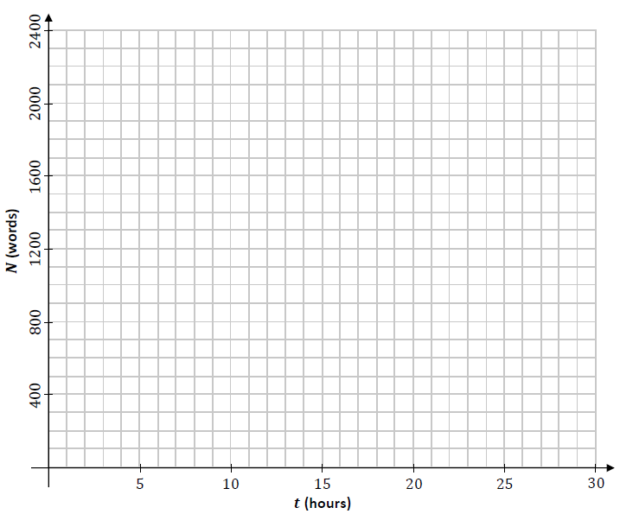

Sample Paper HL Question 5 (b)
A rumour may be spread when a person who has heard the rumour interacts with a person who has not heard the rumour.
Therefore, the rate of spread of a rumour within a group can be modelled as being proportional to the product of the number of people in the group who have heard the rumour and the number of people in the group who have not heard it.
A student models the rate at which a certain rumour spreads within a school population of 1200 students using the differential equation:
$$\frac{dR}{dt}=kR(1200-R)$$
where 𝑅(t) is the number of students of that school who have heard the rumour at time 𝑡, measured in days, and where 𝑘 is a positive constant.
On Monday morning (𝑡 = 100), 100 students had heard the rumour.

- Solve the differential equation to find an expression that relates 𝑅, 𝑘 and 𝑡.

Note that $\frac{1}{y(x-y)}=\frac{1}{x}(\frac{1}{y}+\frac{1}{x-y})$

- By Wednesday morning 250 students had heard the rumour. Calculate the value of 𝑘.

- Sketch the shape of a graph of 𝑅 against 𝑡 to show how the model predicts the spread of the rumour.
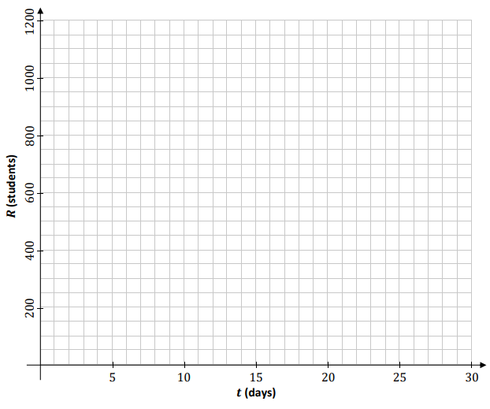
Sample Paper HL Question 8
{This question has been edited as the original question required students to use both difference equations and differential equations to solve}.

A group of scientists are investigating the population, 𝑃, of rabbits on a certain island. They estimate that there are 8000 rabbits on the island and that the population is growing at a constant rate of 3% per year.
The scientists plan to remove a number of rabbits from the island every year, to help populate another habitat. They develop mathematical models to predict how 𝑃 will change if 𝐵 rabbits are removed from the island every year.

The model which the scientists develop uses a differential equation to express the rate of change of 𝑃 with respect to 𝑛, time measured in years.
The differential equation is:
$$\frac{dP}{dN}=0.03P-B$$

where 𝑛 $≥$0, 𝑛∈ℤ and 𝑃₀ = 8000.

- Solve this differential equation to find an expression for 𝑃 in terms of 𝑛 and 𝐵.

The scientists want to know what each model predicts the rabbit population on the island will be after 50 years, if 200 rabbits are removed each year.
- Calculate 𝑃₅₀ using this model when 𝐵 = 200.
- This model makes an assumption about the removal of the rabbits from the island.
What is that assumption?
- The scientists want to know what value of 𝐵 should be chosen so as to keep the rabbit population on the island constant. Calculate this value of 𝐵 using this model.

Integration and differentiation

Sample Paper HL Question 6
A learner driver is practising driving around a roundabout.

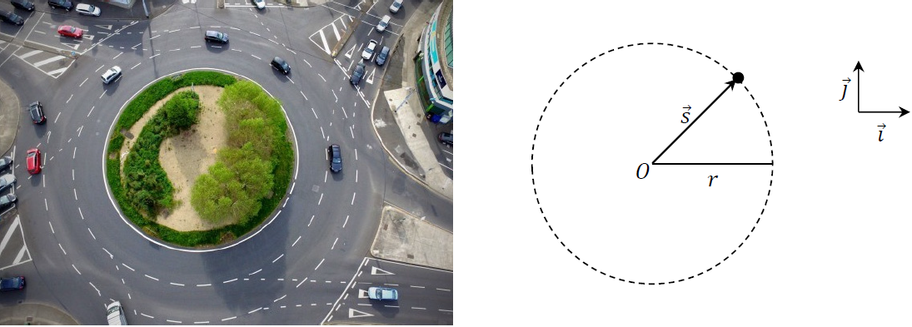

The motion of the car may be modelled as horizontal circular motion around centre 𝑂, with radius 𝑟 and constant angular speed 𝜔, as in the diagram above.
- Write an expression for $\vec{s}$, the displacement of the car relative to 𝑂 at any time 𝑡, in terms of 𝑟, 𝜔 and 𝑡.
Your expression should use the unit vectors 𝚤⃗ and 𝚥⃗.
Note that t = 0 when 𝑠⃗ is along the 𝚤⃗ axis.

- Derive an expression for 𝑣⃗, the velocity of the car at any time 𝑡.

- Use a dot product calculation to show that the car’s velocity and displacement are always perpendicular to each other.

- Show that the acceleration of the car is always directed towards 𝑂.

- Derive an expression for the maximum velocity the car could have as it travels around the roundabout, without slipping. Your expression should be written in terms of 𝑟, 𝑔 and 𝜇, the coefficient of friction between the car and the road.

- Use dimensional analysis to show that the units for the expression you derived in part (v) are equivalent to the units for velocity.

- Do you think the assumptions made in developing this model were appropriate?
Explain your answer.

